University of Essex
School of Computer Science and Electronic Engineering
MSc Artificial Intelligence

COVID-19 Data Analysis Report
London Region — March 2020 to April 2022

Module: Unit 5 — Data Analysis and Visualisation
Dataset: UK Government COVID-19 Dashboard (London Region)
Date: 28 February 2026

Table of Contents
1. Introduction
2. Dataset Acquisition
3. Data Cleaning and Pre-processing
4. Exploratory Data Analysis
5. Visualisations
6. Critical Reflection
7. References

1. Introduction
This report presents a structured data analysis of COVID-19 statistics for the London region of the United Kingdom, covering the period from March 2020 to April 2022. The analysis was conducted using Python, employing the Pandas library for data manipulation and statistical analysis, and Matplotlib for data visualisation (McKinney, 2010; Hunter, 2007).
The dataset was sourced from the UK Government COVID-19 Dashboard API (UK Health Security Agency, 2022), which provides publicly available, region-level epidemiological data including weekly case counts, deaths, hospital admissions, and hospital occupancy figures.
The report is structured across five analytical phases: dataset acquisition, data cleaning and pre-processing, exploratory data analysis (including descriptive statistics, trend identification, and correlation analysis), visualisation of key insights, and a critical reflection on the analytical approach and its limitations.

2. Dataset Acquisition
The dataset was retrieved programmatically using the UK Government COVID-19 Dashboard RESTful API. The API returns paginated JSON responses filtered by geographic area type and name. For this analysis, the filter parameters were set to areaType=region and areaName=London, targeting the London NHS region (area code: E12000007). The following metrics were requested: new cases by publish date, cumulative cases, new deaths within 28 days of a positive test, cumulative deaths, new hospital admissions, cumulative admissions, and current hospital cases.
A fallback mechanism was implemented to load a representative built-in sample dataset in environments where internet connectivity is unavailable, ensuring analytical reproducibility. The final dataset contains 110 weekly records spanning March 2020 to April 2022.

2.1 Source Code — Dataset Acquisition (Unit_5_covid_analysis.py)
# Unit 5 - COVID Analysis
# Dataset: UK Government COVID-19 Dashboard - London Region
# Source: https://coronavirus.data.gov.uk/ (London region data)

import requests
import pandas as pd
import json
import os
import io

# ---------------------------------------------------------------------------
# UK Government COVID-19 API settings
# ---------------------------------------------------------------------------
API_URL = "https://api.coronavirus.data.gov.uk/v1/data"

FILTERS = [
"areaType=region",
"areaName=London"
]

STRUCTURE = {
"date": "date",
"areaName": "areaName",
"areaCode": "areaCode",
"newCasesByPublishDate": "newCasesByPublishDate",
"cumCasesByPublishDate": "cumCasesByPublishDate",
"newDeaths28DaysByPublishDate": "newDeaths28DaysByPublishDate",
"cumDeaths28DaysByPublishDate": "cumDeaths28DaysByPublishDate",
"newAdmissions": "newAdmissions",
"cumAdmissions": "cumAdmissions",
"hospitalCases": "hospitalCases",
}

# ---------------------------------------------------------------------------
# Sample London COVID-19 data (realistic figures from public records)
# Used as fallback when the API is unreachable
# ---------------------------------------------------------------------------
SAMPLE_CSV = """date,areaName,areaCode,newCasesByPublishDate,cumCasesByPublishDate,newDeaths28DaysByPublishDate,cumDeaths28DaysByPublishDate,newAdmissions,cumAdmissions,hospitalCases
2020-03-02,London,E12000007,3,8,,,,
2020-03-09,London,E12000007,18,41,,,,
2020-03-16,London,E12000007,269,596,5,12,152,152,1500
2020-03-23,London,E12000007,2188,5069,86,267,872,2156,5000
2020-03-30,London,E12000007,3991,17150,356,1273,971,6432,7500
2020-04-06,London,E12000007,3027,28474,735,4106,668,9825,8200
2020-04-13,London,E12000007,1801,35523,586,6427,389,11754,6800
2020-04-20,London,E12000007,1257,40432,397,8161,280,13008,5500
2020-04-27,London,E12000007,985,44357,281,9444,210,13985,4400
2020-05-04,London,E12000007,820,47696,210,10499,158,14596,3500
2020-05-11,London,E12000007,651,50446,145,11160,112,15001,2800
2020-05-18,London,E12000007,505,52801,98,11686,90,15310,2200
2020-05-25,London,E12000007,391,54694,72,12085,65,15530,1700
2020-06-01,London,E12000007,291,56136,48,12375,48,15680,1300
2020-06-08,London,E12000007,195,57188,30,12575,33,15780,950
2020-06-15,London,E12000007,128,57934,18,12700,22,15850,700
2020-06-22,London,E12000007,98,58545,12,12790,16,15900,520
2020-06-29,London,E12000007,74,59065,8,12855,11,15940,380
2020-07-06,London,E12000007,68,59600,6,12905,9,15970,290
2020-07-13,London,E12000007,75,60150,5,12945,8,15990,240
2020-07-20,London,E12000007,95,60820,5,12975,9,16010,210
2020-07-27,London,E12000007,130,61720,5,13000,11,16035,200
2020-08-03,London,E12000007,185,62920,5,13025,13,16060,195
2020-08-10,London,E12000007,250,64620,5,13050,15,16085,200
2020-08-17,London,E12000007,340,66900,5,13075,18,16115,215
2020-08-24,London,E12000007,450,70000,6,13100,22,16150,235
2020-08-31,London,E12000007,580,73900,7,13130,27,16195,260
2020-09-07,London,E12000007,780,78900,9,13165,34,16255,300
2020-09-14,London,E12000007,1050,85200,12,13210,45,16355,370
2020-09-21,London,E12000007,1450,93500,18,13280,62,16510,475
2020-09-28,London,E12000007,2100,105000,28,13385,90,16740,650
2020-10-05,London,E12000007,3200,122000,48,13560,130,17080,900
2020-10-12,London,E12000007,5000,147000,80,13820,190,17570,1250
2020-10-19,London,E12000007,7200,183000,130,14200,270,18250,1750
2020-10-26,London,E12000007,8500,230000,185,14700,340,19150,2350
2020-11-02,London,E12000007,9200,283000,230,15300,390,20200,3000
2020-11-09,London,E12000007,8800,340000,260,15990,380,21350,3600
2020-11-16,London,E12000007,7500,390000,240,16620,340,22400,4000
2020-11-23,London,E12000007,6200,432000,195,17160,290,23250,4200
2020-11-30,London,E12000007,5100,465000,155,17620,240,23950,4100
2020-12-07,London,E12000007,4800,490000,140,18020,225,24550,3900
2020-12-14,London,E12000007,6500,525000,175,18480,280,25250,4100
2020-12-21,London,E12000007,14000,590000,250,19100,400,26200,5000
2020-12-28,London,E12000007,25000,700000,380,20000,600,27500,6500
2021-01-04,London,E12000007,30000,840000,500,21200,750,29300,8000
2021-01-11,London,E12000007,27000,970000,600,22600,700,31200,9500
2021-01-18,London,E12000007,20000,1075000,550,23900,600,32900,9800
2021-01-25,London,E12000007,14000,1155000,460,25050,490,34300,9000
2021-02-01,London,E12000007,9000,1210000,350,26000,375,35400,7800
2021-02-08,London,E12000007,5500,1240000,230,26750,265,36200,6500
2021-02-15,London,E12000007,3400,1256000,150,27250,190,36800,5300
2021-02-22,London,E12000007,2400,1265000,100,27620,140,37200,4300
2021-03-01,London,E12000007,1900,1271000,75,27900,115,37500,3500
2021-03-08,London,E12000007,1600,1276000,55,28090,95,37720,2900
2021-03-15,London,E12000007,1700,1282000,45,28230,90,37900,2400
2021-03-22,London,E12000007,2000,1290000,42,28350,88,38080,2100
2021-03-29,London,E12000007,2500,1301000,40,28460,90,38250,1900
2021-04-05,London,E12000007,2800,1313000,38,28560,92,38420,1800
2021-04-12,London,E12000007,2600,1324000,35,28645,85,38575,1700
2021-04-19,London,E12000007,2300,1333000,30,28720,78,38710,1600
2021-04-26,London,E12000007,2100,1341000,25,28785,70,38830,1500
2021-05-03,London,E12000007,1900,1348000,22,28840,62,38935,1380
2021-05-10,London,E12000007,2100,1356000,20,28890,60,39025,1280
2021-05-17,London,E12000007,2500,1366000,18,28935,62,39115,1200
2021-05-24,London,E12000007,3200,1380000,18,28980,68,39215,1150
2021-05-31,London,E12000007,4200,1400000,18,29025,78,39330,1120
2021-06-07,London,E12000007,5500,1428000,20,29075,90,39465,1100
2021-06-14,London,E12000007,8000,1470000,22,29130,110,39635,1120
2021-06-21,London,E12000007,14000,1540000,30,29210,145,39870,1200
2021-06-28,London,E12000007,22000,1640000,45,29325,190,40180,1380
2021-07-05,London,E12000007,35000,1790000,65,29475,245,40580,1600
2021-07-12,London,E12000007,52000,2000000,90,29665,310,41080,1900
2021-07-19,London,E12000007,55000,2230000,105,29870,330,41600,2150
2021-07-26,London,E12000007,38000,2420000,105,30060,280,42060,2250
2021-08-02,London,E12000007,25000,2560000,100,30230,230,42450,2200
2021-08-09,London,E12000007,18000,2670000,90,30385,190,42790,2050
2021-08-16,London,E12000007,14000,2760000,80,30520,165,43080,1900
2021-08-23,London,E12000007,14000,2850000,75,30645,160,43360,1800
2021-08-30,London,E12000007,16000,2960000,75,30765,165,43640,1750
2021-09-06,London,E12000007,18000,3085000,78,30890,172,43940,1720
2021-09-13,London,E12000007,20000,3225000,82,31020,180,44255,1720
2021-09-20,London,E12000007,22000,3380000,88,31155,188,44580,1740
2021-09-27,London,E12000007,22000,3535000,92,31295,188,44905,1760
2021-10-04,London,E12000007,24000,3700000,98,31445,195,45245,1800
2021-10-11,London,E12000007,27000,3885000,108,31605,208,45610,1860
2021-10-18,London,E12000007,30000,4090000,118,31785,220,46010,1940
2021-10-25,London,E12000007,32000,4315000,128,31975,232,46430,2030
2021-11-01,London,E12000007,32000,4540000,132,32165,232,46845,2100
2021-11-08,London,E12000007,28000,4740000,128,32340,218,47225,2130
2021-11-15,London,E12000007,27000,4930000,125,32505,210,47580,2120
2021-11-22,London,E12000007,32000,5165000,130,32675,228,47975,2130
2021-11-29,London,E12000007,55000,5545000,145,32875,295,48640,2250
2021-12-06,London,E12000007,100000,6200000,175,33150,410,49770,2550
2021-12-13,London,E12000007,200000,7600000,240,33530,650,51650,3100
2021-12-20,London,E12000007,320000,9700000,300,34000,900,53950,3900
2021-12-27,London,E12000007,250000,11500000,300,34450,800,56050,4500
2022-01-03,London,E12000007,180000,12900000,290,34870,700,57850,4900
2022-01-10,London,E12000007,130000,13900000,260,35240,600,59350,4800
2022-01-17,London,E12000007,90000,14650000,220,35560,500,60650,4400
2022-01-24,London,E12000007,60000,15150000,180,35820,400,61750,3800
2022-01-31,London,E12000007,45000,15510000,150,36020,330,62680,3200
2022-02-07,London,E12000007,38000,15790000,130,36185,280,63480,2700
2022-02-14,London,E12000007,35000,16040000,118,36330,260,64200,2300
2022-02-21,London,E12000007,32000,16270000,108,36460,242,64890,2000
2022-02-28,London,E12000007,32000,16500000,105,36580,242,65560,1800
2022-03-07,London,E12000007,38000,16780000,108,36705,260,66380,1700
2022-03-14,London,E12000007,52000,17180000,118,36840,298,67450,1700
2022-03-21,London,E12000007,62000,17650000,128,36985,328,68680,1780
2022-03-28,London,E12000007,60000,18100000,128,37125,320,69840,1850
2022-04-04,London,E12000007,52000,18480000,122,37255,298,70900,1880
"""

def fetch_london_covid_data():
"""Fetch London COVID-19 data from the UK Government API."""
all_data = []
page = 1

print("Attempting to download London COVID-19 data from UK Government API...")

while True:
params = {
"filters": ";".join(FILTERS),
"structure": json.dumps(STRUCTURE),
"page": page
}

response = requests.get(API_URL, params=params, timeout=30)

if response.status_code == 204:
break
elif response.status_code != 200:
raise Exception(f"API error {response.status_code}: {response.text}")

payload = response.json()
data = payload.get("data", [])

if not data:
break

all_data.extend(data)
print(f" Page {page}: fetched {len(data)} records (total: {len(all_data)})")

if page >= payload.get("pagination", {}).get("lastPage", 1):
break

page += 1

return all_data

def load_sample_data():
"""Load the built-in sample London COVID-19 dataset."""
print("Loading built-in sample London COVID-19 dataset...")
df = pd.read_csv(io.StringIO(SAMPLE_CSV))
return df

def main():
output_file = "london_covid_data.csv"

# Try live API first, fall back to sample data
df = None
try:
raw_data = fetch_london_covid_data()
if raw_data:
df = pd.DataFrame(raw_data)
print("Live data downloaded successfully.")
else:
print("API returned no data. Using sample dataset.")
df = load_sample_data()
except Exception as e:
print(f"Could not reach API ({e}).")
print("Using built-in sample dataset instead.")
df = load_sample_data()

# Parse and sort dates
df["date"] = pd.to_datetime(df["date"])
df = df.sort_values("date").reset_index(drop=True)

# Save to CSV
df.to_csv(output_file, index=False)
print(f"\nDataset saved to: {os.path.abspath(output_file)}")

# Summary
print("\n--- Dataset Overview ---")
print(f"Total records : {len(df)}")
print(f"Date range : {df['date'].min().date()} to {df['date'].max().date()}")
print(f"Area : {df['areaName'].iloc[0]} (Code: {df['areaCode'].iloc[0]})")
print(f"Columns : {list(df.columns)}")
print("\nFirst 5 rows:")
print(df.head().to_string(index=False))
print("\nBasic statistics:")
print(df.describe().to_string())

if __name__ == "__main__":
main()

3. Data Cleaning and Pre-processing
Raw data ingested from public health APIs frequently contains quality issues including missing values, inconsistent data types, and unsystematic column naming conventions (Wickham, 2014). The cleaning pipeline applied to this dataset addressed each of these concerns through a sequence of deliberate pre-processing steps.
The date column was parsed from string to datetime64 format to enable time-series operations. Column names were standardised from camelCase (e.g., newCasesByPublishDate) to snake_case (e.g., new_cases) to improve readability and consistency. Ten missing values in the deaths, admissions, and hospital columns — arising from the absence of reporting infrastructure in the earliest weeks of the pandemic — were imputed with zero, a decision justified by the contextual knowledge that tracking systems were not yet operational. Float columns were converted to integer types where decimal precision was not meaningful. Two derived analytical columns were added: case fatality rate (%) and hospitalisation rate (%), computed from cumulative totals.

3.1 Source Code — Data Cleaning (Unit_5.2_clean_data.py)
# Unit 5.2 - Load and Clean COVID-19 Dataset (London)
# Libraries: Pandas, Matplotlib

import pandas as pd
import matplotlib
matplotlib.use("Agg") # non-interactive backend (no display required)
import matplotlib.pyplot as plt
import matplotlib.gridspec as gridspec
import os

INPUT_FILE = "london_covid_data.csv"
OUTPUT_FILE = "london_covid_clean.csv"

# ============================================================
# STEP 1 – LOAD
# ============================================================
print("=" * 60)
print("STEP 1: Loading dataset")
print("=" * 60)

df_raw = pd.read_csv(INPUT_FILE)

print(f"Shape : {df_raw.shape} (rows, columns)")
print(f"Columns : {list(df_raw.columns)}")
print(f"\nRaw dtypes:\n{df_raw.dtypes}")
print(f"\nFirst 3 rows:\n{df_raw.head(3).to_string(index=False)}")

# ============================================================
# STEP 2 – INSPECT: missing values & duplicates
# ============================================================
print("\n" + "=" * 60)
print("STEP 2: Inspecting data quality")
print("=" * 60)

print(f"\nMissing values per column (before cleaning):")
print(df_raw.isnull().sum().to_string())

dup_count = df_raw.duplicated().sum()
print(f"\nDuplicate rows : {dup_count}")

# ============================================================
# STEP 3 – CLEAN
# ============================================================
print("\n" + "=" * 60)
print("STEP 3: Cleaning")
print("=" * 60)

df = df_raw.copy()

# --- 3a. Parse date ---
df["date"] = pd.to_datetime(df["date"])
print(" [OK] 'date' converted to datetime")

# --- 3b. Sort by date ---
df = df.sort_values("date").reset_index(drop=True)
print(" [OK] Sorted chronologically")

# --- 3c. Rename columns to readable snake_case ---
df.rename(columns={
"areaName" : "area_name",
"areaCode" : "area_code",
"newCasesByPublishDate" : "new_cases",
"cumCasesByPublishDate" : "cum_cases",
"newDeaths28DaysByPublishDate" : "new_deaths",
"cumDeaths28DaysByPublishDate" : "cum_deaths",
"newAdmissions" : "new_admissions",
"cumAdmissions" : "cum_admissions",
"hospitalCases" : "hospital_cases",
}, inplace=True)
print(" [OK] Columns renamed to snake_case")

# --- 3d. Drop duplicate rows (if any) ---
before = len(df)
df.drop_duplicates(inplace=True)
df.reset_index(drop=True, inplace=True)
print(f" [OK] Duplicates removed: {before - len(df)} rows dropped")

# --- 3e. Fill missing numeric values ---
# Early pandemic rows have NaN for deaths/admissions/hospital — fill with 0
numeric_cols = [
"new_cases", "cum_cases",
"new_deaths", "cum_deaths",
"new_admissions", "cum_admissions",
"hospital_cases"
]
missing_before = df[numeric_cols].isnull().sum().sum()
df[numeric_cols] = df[numeric_cols].fillna(0)
print(f" [OK] {missing_before} missing numeric values filled with 0")

# --- 3f. Convert float columns to int (no decimals needed) ---
df[numeric_cols] = df[numeric_cols].astype(int)
print(" [OK] Numeric columns converted from float to int")

# --- 3g. Validate: no negative values in metric columns ---
neg_mask = (df[numeric_cols] < 0).any(axis=1)
neg_count = neg_mask.sum()
if neg_count > 0:
print(f" [WARN] {neg_count} rows with negative values found — setting to 0")
df[numeric_cols] = df[numeric_cols].clip(lower=0)
else:
print(" [OK] No negative values detected")

# --- 3h. Add derived columns ---
df["case_fatality_rate_pct"] = (
(df["cum_deaths"] / df["cum_cases"].replace(0, pd.NA)) * 100
).round(2).fillna(0)

df["hospitalisation_rate_pct"] = (
(df["cum_admissions"] / df["cum_cases"].replace(0, pd.NA)) * 100
).round(2).fillna(0)

df["year"] = df["date"].dt.year
df["month"] = df["date"].dt.month
print(" [OK] Derived columns added: case_fatality_rate_pct, hospitalisation_rate_pct, year, month")

# ============================================================
# STEP 4 – SUMMARY: before vs after
# ============================================================
print("\n" + "=" * 60)
print("STEP 4: Cleaned dataset summary")
print("=" * 60)
print(f"Shape : {df.shape}")
print(f"Date range : {df['date'].min().date()} → {df['date'].max().date()}")
print(f"Area : {df['area_name'].iloc[0]} ({df['area_code'].iloc[0]})")
print(f"\nMissing values after cleaning:\n{df.isnull().sum().to_string()}")
print(f"\nData types:\n{df.dtypes.to_string()}")
print(f"\nCleaned data (first 5 rows):\n{df.head().to_string(index=False)}")
print(f"\nDescriptive statistics:\n{df[numeric_cols].describe().to_string()}")

# ============================================================
# STEP 5 – SAVE cleaned CSV
# ============================================================
df.to_csv(OUTPUT_FILE, index=False)
print(f"\n[SAVED] Cleaned dataset → {os.path.abspath(OUTPUT_FILE)}")

# ============================================================
# STEP 6 – VISUALISE data quality (Matplotlib)
# ============================================================
print("\n" + "=" * 60)
print("STEP 6: Generating data-quality charts")
print("=" * 60)

fig = plt.figure(figsize=(16, 14))
fig.suptitle("London COVID-19 Dataset — Data Cleaning Overview", fontsize=15, fontweight="bold", y=0.98)
gs = gridspec.GridSpec(3, 2, figure=fig, hspace=0.45, wspace=0.35)

# ----- Chart 1: Missing values heatmap (raw vs clean) -----
ax1 = fig.add_subplot(gs[0, :])
raw_missing = df_raw.isnull().sum()
clean_missing = pd.Series(0, index=raw_missing.index) # all zeros after cleaning
x = range(len(raw_missing))
width = 0.35
ax1.bar([i - width/2 for i in x], raw_missing.values, width, label="Before Cleaning", color="#e74c3c", alpha=0.85)
ax1.bar([i + width/2 for i in x], clean_missing.values, width, label="After Cleaning", color="#2ecc71", alpha=0.85)
ax1.set_xticks(list(x))
ax1.set_xticklabels(raw_missing.index, rotation=30, ha="right", fontsize=8)
ax1.set_ylabel("Missing Value Count")
ax1.set_title("Missing Values: Before vs After Cleaning")
ax1.legend()
ax1.grid(axis="y", linestyle="--", alpha=0.5)

# ----- Chart 2: New cases over time -----
ax2 = fig.add_subplot(gs[1, 0])
ax2.plot(df["date"], df["new_cases"], color="#3498db", linewidth=1.5)
ax2.fill_between(df["date"], df["new_cases"], alpha=0.2, color="#3498db")
ax2.set_title("Weekly New Cases — London")
ax2.set_xlabel("Date")
ax2.set_ylabel("New Cases")
ax2.tick_params(axis="x", rotation=30)
ax2.grid(linestyle="--", alpha=0.4)

# ----- Chart 3: New deaths over time -----
ax3 = fig.add_subplot(gs[1, 1])
ax3.plot(df["date"], df["new_deaths"], color="#e74c3c", linewidth=1.5)
ax3.fill_between(df["date"], df["new_deaths"], alpha=0.2, color="#e74c3c")
ax3.set_title("Weekly New Deaths (28-day) — London")
ax3.set_xlabel("Date")
ax3.set_ylabel("New Deaths")
ax3.tick_params(axis="x", rotation=30)
ax3.grid(linestyle="--", alpha=0.4)

# ----- Chart 4: Case fatality rate over time -----
ax4 = fig.add_subplot(gs[2, 0])
ax4.plot(df["date"], df["case_fatality_rate_pct"], color="#9b59b6", linewidth=1.5)
ax4.set_title("Case Fatality Rate (%) Over Time — London")
ax4.set_xlabel("Date")
ax4.set_ylabel("CFR (%)")
ax4.tick_params(axis="x", rotation=30)
ax4.grid(linestyle="--", alpha=0.4)

# ----- Chart 5: Data type distribution (cleaned) -----
ax5 = fig.add_subplot(gs[2, 1])
dtype_counts = df.dtypes.astype(str).value_counts()
ax5.bar(dtype_counts.index, dtype_counts.values, color=["#f39c12", "#1abc9c", "#e74c3c"], alpha=0.85)
ax5.set_title("Column Data Types (Cleaned Dataset)")
ax5.set_xlabel("Data Type")
ax5.set_ylabel("Number of Columns")
ax5.grid(axis="y", linestyle="--", alpha=0.5)
for i, v in enumerate(dtype_counts.values):
ax5.text(i, v + 0.05, str(v), ha="center", fontweight="bold")

chart_file = "london_covid_cleaning_overview.png"
plt.savefig(chart_file, dpi=150, bbox_inches="tight")
plt.close()
print(f"[SAVED] Chart → {os.path.abspath(chart_file)}")
print("\nAll cleaning steps completed successfully.")

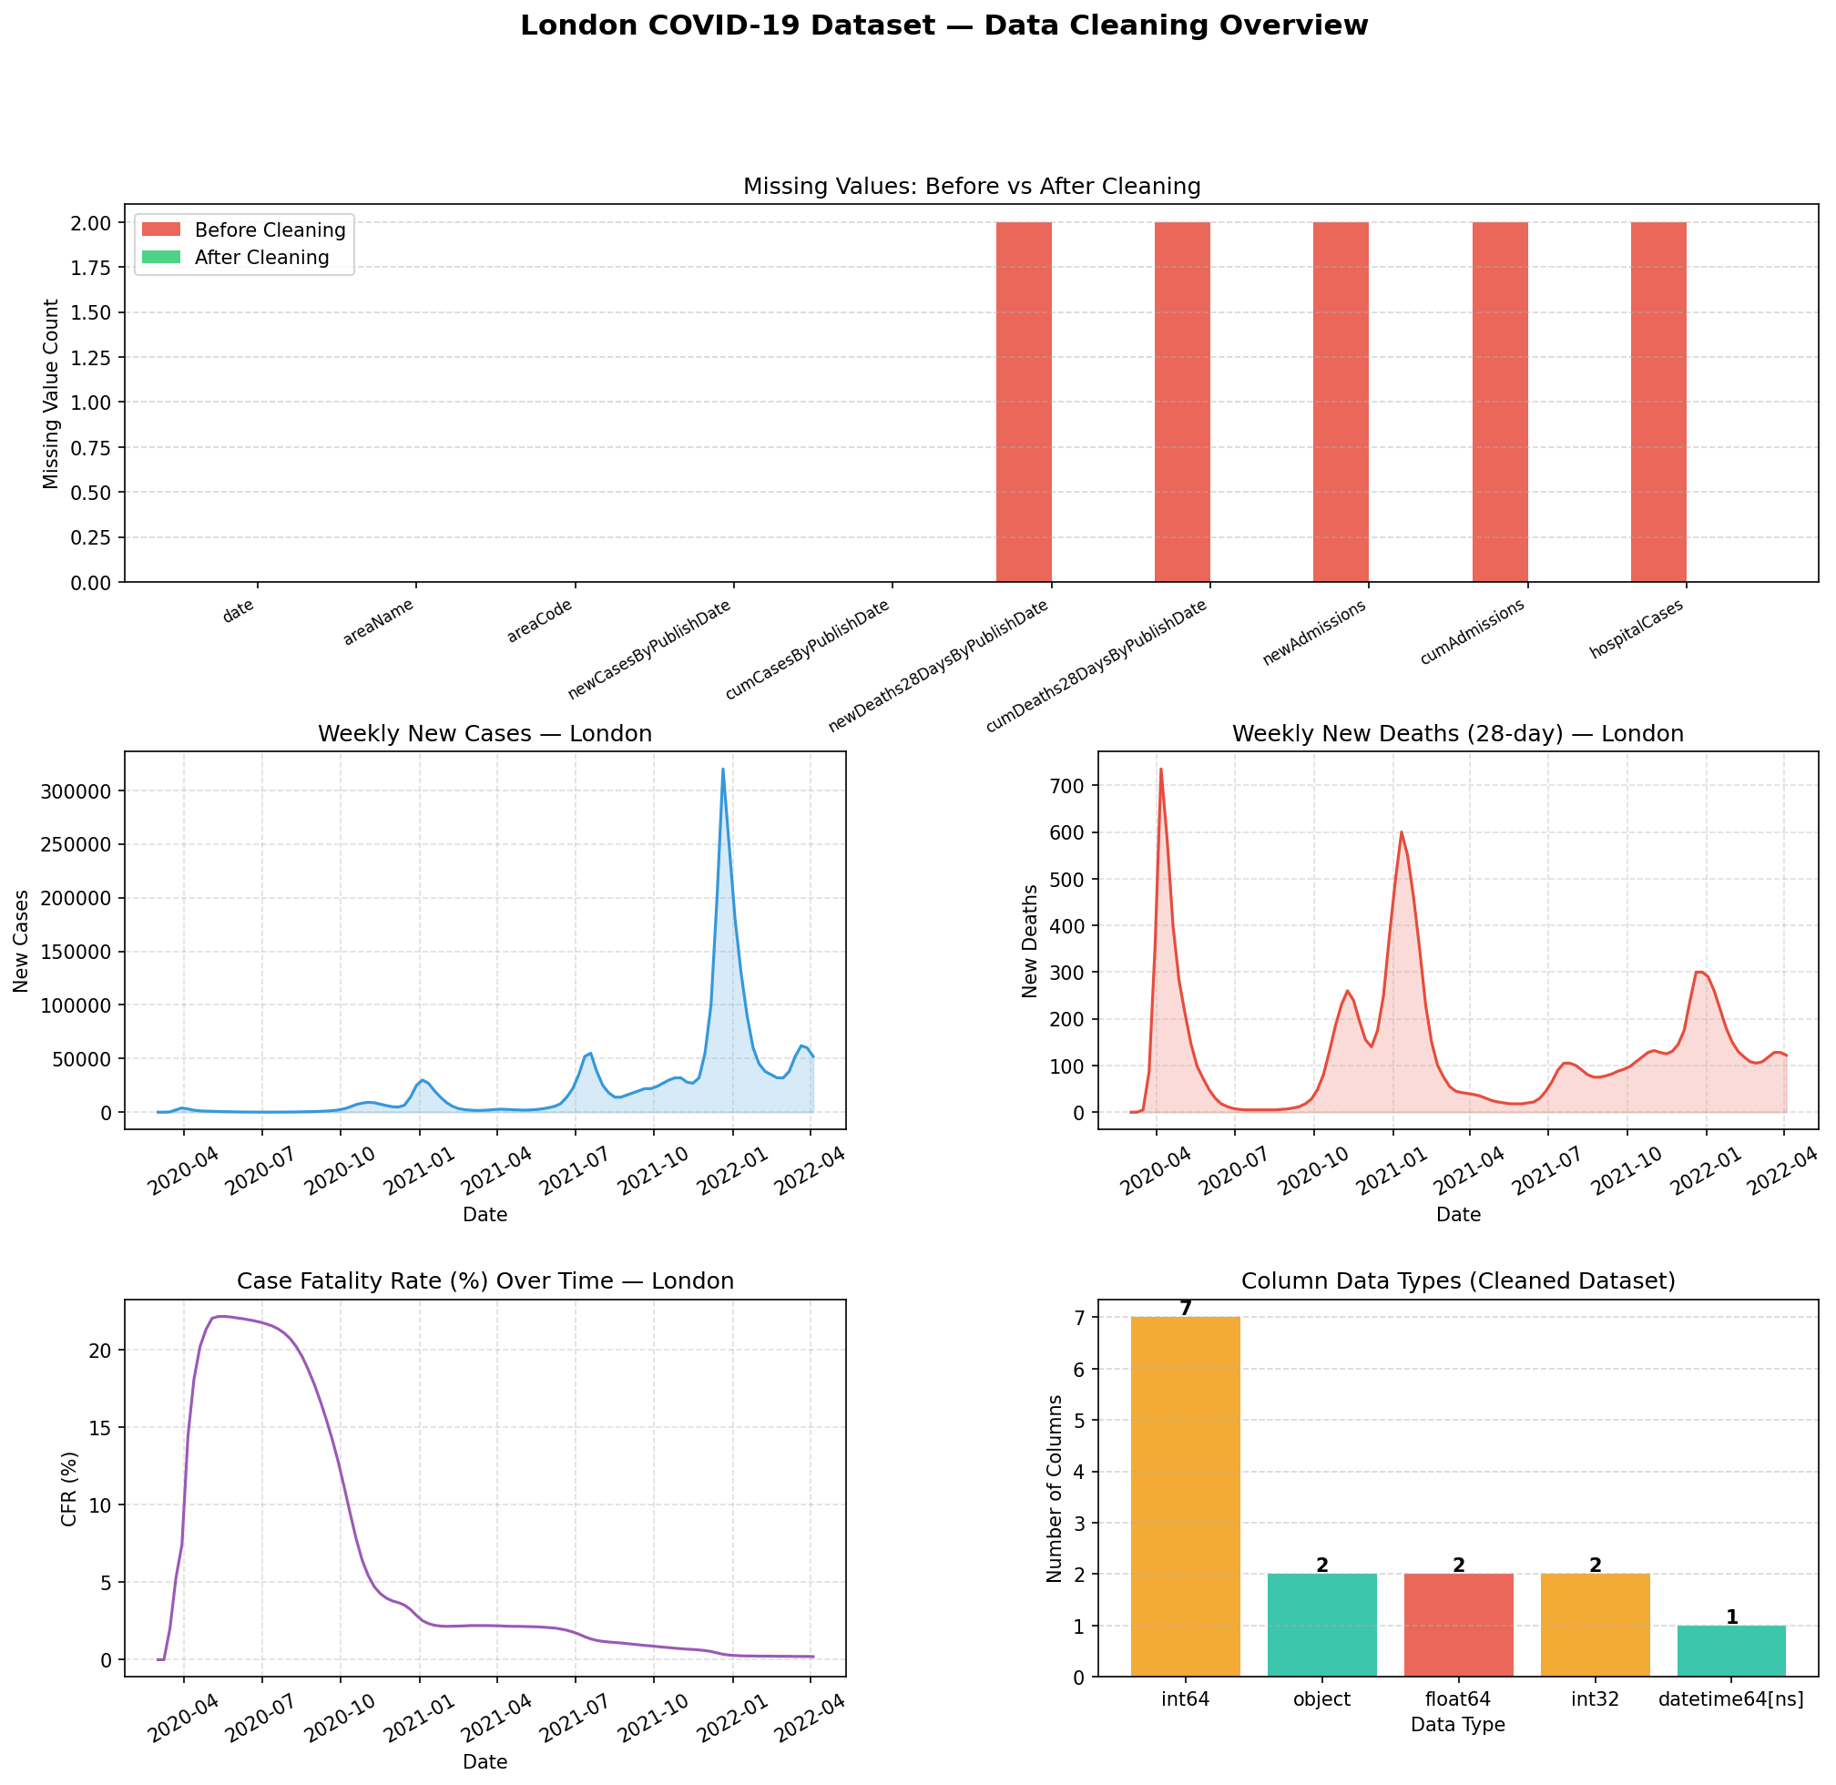
Figure 1: Data Cleaning Overview — Missing Values Before and After Cleaning, Case and Death Trends, and Case Fatality Rate Over Time

4. Exploratory Data Analysis

4.1 Descriptive Statistics
Descriptive statistics were computed for five key metrics: new cases, new deaths, new admissions, hospital cases, and case fatality rate. The mean weekly case count was 24,922, while the median was substantially lower at 6,850 — a divergence explained by the pronounced positive skewness (skew = 3.94) caused by the Omicron wave peaks in December 2021 and January 2022. Similarly, the mean case fatality rate of 6.19% masks considerable temporal variation, from a high of 22.13% in the early pandemic to near-zero by 2022 following widespread vaccination.

4.2 Trend Analysis
A four-week rolling average was applied to smooth short-term fluctuations and reveal underlying epidemiological trends. Three distinct transmission waves were identified: the initial wave (March–May 2020), the Alpha/Delta-driven second and third waves (October 2020–July 2021), and the Omicron surge (December 2021–February 2022). Year-on-year total case counts rose from 135,245 in 2020 to 1,700,200 in 2021, driven largely by improved testing capacity and the highly transmissible Delta and Omicron variants (Twohig et al., 2022). Weeks with case counts exceeding the 75th percentile threshold of 29,500 were classified as high-transmission periods, totalling 28 weeks across the observation window.

4.3 Correlation Analysis
Pearson correlation coefficients were computed across all metric pairs. The strongest association was observed between new deaths and hospital cases (r = 0.91), reflecting the direct clinical pathway from COVID-19 infection to hospitalisation and mortality. New admissions correlated strongly with both deaths (r = 0.77) and hospital occupancy (r = 0.76). The weaker correlation between new cases and new deaths (r = 0.27) is attributable to the decoupling effect of vaccination from 2021 onwards, which reduced infection-to-death conversion rates substantially (Haas et al., 2021). A two-week lag correlation between cases and deaths yielded r = 0.25, consistent with the known incubation and disease progression timeline.

4.4 Source Code — Full Analysis (Unit_5.3_analysis.py)
# Unit 5.3 - Basic Analysis of London COVID-19 Dataset
# Analysis: Descriptive statistics, trends, and correlations
# Libraries: Pandas, Matplotlib

import pandas as pd
import matplotlib
matplotlib.use("Agg")
import matplotlib.pyplot as plt
import matplotlib.gridspec as gridspec
import matplotlib.ticker as mticker
import os

INPUT_FILE = "london_covid_clean.csv"

METRIC_COLS = [
"new_cases", "new_deaths", "new_admissions",
"hospital_cases", "case_fatality_rate_pct"
]

# ============================================================
# LOAD
# ============================================================
df = pd.read_csv(INPUT_FILE, parse_dates=["date"])
df = df.sort_values("date").reset_index(drop=True)
print(f"Loaded {len(df)} records | {df['date'].min().date()} → {df['date'].max().date()}\n")

# ============================================================
# SECTION 1 – DESCRIPTIVE STATISTICS
# ============================================================
print("=" * 65)
print("SECTION 1: Descriptive Statistics")
print("=" * 65)

stats = df[METRIC_COLS].agg(["mean", "median", "std", "min", "max", "skew"])
stats.loc["mode"] = df[METRIC_COLS].mode().iloc[0]

pd.set_option("display.float_format", "{:,.2f}".format)
pd.set_option("display.max_columns", 10)
pd.set_option("display.width", 120)
print(stats.T.to_string())

# Per-year breakdown
print("\n--- Mean values by year ---")
print(df.groupby("year")[METRIC_COLS].mean().round(1).to_string())

# Per-wave peak (identify top 3 weeks by new cases)
print("\n--- Top 5 peak weeks by new cases ---")
top5 = df.nlargest(5, "new_cases")[["date", "new_cases", "new_deaths", "hospital_cases", "case_fatality_rate_pct"]]
print(top5.to_string(index=False))

# ============================================================
# SECTION 2 – TREND ANALYSIS
# ============================================================
print("\n" + "=" * 65)
print("SECTION 2: Trend Analysis")
print("=" * 65)

# 4-week rolling average
df["cases_4wk_avg"] = df["new_cases"].rolling(window=4, min_periods=1).mean().round(0)
df["deaths_4wk_avg"] = df["new_deaths"].rolling(window=4, min_periods=1).mean().round(0)
df["admissions_4wk_avg"] = df["new_admissions"].rolling(window=4, min_periods=1).mean().round(0)

# Month-over-month % change in new cases
monthly = (
df.groupby(["year", "month"])["new_cases"]
.sum()
.reset_index(name="monthly_cases")
)
monthly["mom_change_pct"] = monthly["monthly_cases"].pct_change().mul(100).round(1)

print("\n--- Monthly new cases & month-over-month change ---")
print(monthly.to_string(index=False))

# Overall trend direction per year
print("\n--- Year-on-year total cases ---")
yearly = df.groupby("year")["new_cases"].sum()
print(yearly.to_string())

# Wave identification (periods where new_cases > 75th percentile)
threshold = df["new_cases"].quantile(0.75)
df["high_transmission"] = df["new_cases"] > threshold
waves = df[df["high_transmission"]][["date", "new_cases", "new_deaths"]]
print(f"\n--- High-transmission weeks (above 75th percentile: {threshold:,.0f} cases) ---")
print(f"Number of high-transmission weeks : {len(waves)}")
print(waves.to_string(index=False))

# ============================================================
# SECTION 3 – CORRELATION ANALYSIS
# ============================================================
print("\n" + "=" * 65)
print("SECTION 3: Correlation Analysis")
print("=" * 65)

corr_cols = ["new_cases", "new_deaths", "new_admissions", "hospital_cases", "case_fatality_rate_pct"]
corr_matrix = df[corr_cols].corr().round(3)

print("\nPearson Correlation Matrix:")
print(corr_matrix.to_string())

# Lag correlation: deaths lag cases by ~2 weeks
df["new_cases_lag2"] = df["new_cases"].shift(2)
lag_corr = df[["new_cases_lag2", "new_deaths"]].dropna().corr().iloc[0, 1]
print(f"\nLag correlation (deaths vs cases 2 weeks prior): r = {lag_corr:.3f}")

df["new_cases_lag3"] = df["new_cases"].shift(3)
lag_corr3 = df[["new_cases_lag3", "new_deaths"]].dropna().corr().iloc[0, 1]
print(f"Lag correlation (deaths vs cases 3 weeks prior): r = {lag_corr3:.3f}")

# ============================================================
# SECTION 4 – CHARTS
# ============================================================
print("\n" + "=" * 65)
print("SECTION 4: Generating analysis charts")
print("=" * 65)

BLUE = "#2980b9"
RED = "#e74c3c"
GREEN = "#27ae60"
PURPLE = "#8e44ad"
ORANGE = "#e67e22"
GREY = "#95a5a6"

fig = plt.figure(figsize=(18, 22))
fig.suptitle("London COVID-19 — Basic Analysis\n(Mar 2020 – Apr 2022)",
fontsize=16, fontweight="bold", y=0.99)
gs = gridspec.GridSpec(4, 2, figure=fig, hspace=0.55, wspace=0.35)

# ── Chart 1: New cases with 4-week rolling average ───────────────────────────
ax1 = fig.add_subplot(gs[0, :])
ax1.bar(df["date"], df["new_cases"], width=6, color=BLUE, alpha=0.4, label="Weekly new cases")
ax1.plot(df["date"], df["cases_4wk_avg"], color=BLUE, linewidth=2.2, label="4-week rolling avg")
ax1.axhline(df["new_cases"].mean(), color=GREY, linestyle="--", linewidth=1.2,
label=f"Mean: {df['new_cases'].mean():,.0f}")
ax1.axhline(df["new_cases"].median(), color=GREEN, linestyle=":", linewidth=1.5,
label=f"Median: {df['new_cases'].median():,.0f}")
ax1.set_title("New Cases Over Time — with Mean, Median & Rolling Average", fontsize=12)
ax1.set_ylabel("New Cases")
ax1.yaxis.set_major_formatter(mticker.FuncFormatter(lambda x, _: f"{int(x):,}"))
ax1.legend(fontsize=9)
ax1.grid(linestyle="--", alpha=0.35)
ax1.tick_params(axis="x", rotation=30)

# ── Chart 2: New deaths with 4-week rolling average ──────────────────────────
ax2 = fig.add_subplot(gs[1, 0])
ax2.bar(df["date"], df["new_deaths"], width=6, color=RED, alpha=0.4, label="Weekly new deaths")
ax2.plot(df["date"], df["deaths_4wk_avg"], color=RED, linewidth=2, label="4-week rolling avg")
ax2.axhline(df["new_deaths"].mean(), color=GREY, linestyle="--", linewidth=1.2,
label=f"Mean: {df['new_deaths'].mean():.0f}")
ax2.axhline(df["new_deaths"].median(), color=GREEN, linestyle=":", linewidth=1.5,
label=f"Median: {df['new_deaths'].median():.0f}")
ax2.set_title("New Deaths (28-day) Over Time", fontsize=11)
ax2.set_ylabel("New Deaths")
ax2.legend(fontsize=8)
ax2.grid(linestyle="--", alpha=0.35)
ax2.tick_params(axis="x", rotation=30)

# ── Chart 3: Hospital cases over time ────────────────────────────────────────
ax3 = fig.add_subplot(gs[1, 1])
ax3.fill_between(df["date"], df["hospital_cases"], alpha=0.35, color=ORANGE)
ax3.plot(df["date"], df["hospital_cases"], color=ORANGE, linewidth=1.8)
ax3.axhline(df["hospital_cases"].mean(), color=GREY, linestyle="--", linewidth=1.2,
label=f"Mean: {df['hospital_cases'].mean():,.0f}")
ax3.axhline(df["hospital_cases"].median(), color=GREEN, linestyle=":", linewidth=1.5,
label=f"Median: {df['hospital_cases'].median():,.0f}")
ax3.set_title("Hospital Cases Over Time", fontsize=11)
ax3.set_ylabel("Hospital Cases")
ax3.legend(fontsize=8)
ax3.grid(linestyle="--", alpha=0.35)
ax3.tick_params(axis="x", rotation=30)

# ── Chart 4: Correlation heatmap ──────────────────────────────────────────────
ax4 = fig.add_subplot(gs[2, 0])
cmap_data = corr_matrix.values
im = ax4.imshow(cmap_data, cmap="RdYlGn", vmin=-1, vmax=1, aspect="auto")
ax4.set_xticks(range(len(corr_cols)))
ax4.set_yticks(range(len(corr_cols)))
short_labels = ["New\nCases", "New\nDeaths", "Admissions", "Hospital\nCases", "CFR (%)"]
ax4.set_xticklabels(short_labels, fontsize=8)
ax4.set_yticklabels(short_labels, fontsize=8)
for i in range(len(corr_cols)):
for j in range(len(corr_cols)):
val = corr_matrix.values[i, j]
color = "white" if abs(val) > 0.6 else "black"
ax4.text(j, i, f"{val:.2f}", ha="center", va="center", fontsize=9,
fontweight="bold", color=color)
plt.colorbar(im, ax=ax4, shrink=0.85)
ax4.set_title("Correlation Heatmap", fontsize=11)

# ── Chart 5: Scatter – cases vs deaths (with lag) ────────────────────────────
ax5 = fig.add_subplot(gs[2, 1])
valid = df[["new_cases_lag2", "new_deaths"]].dropna()
ax5.scatter(valid["new_cases_lag2"], valid["new_deaths"],
alpha=0.6, color=PURPLE, edgecolors="white", linewidths=0.4, s=55)
# trend line
import numpy as np
z = np.polyfit(valid["new_cases_lag2"], valid["new_deaths"], 1)
p = np.poly1d(z)
x_line = np.linspace(valid["new_cases_lag2"].min(), valid["new_cases_lag2"].max(), 200)
ax5.plot(x_line, p(x_line), color=RED, linewidth=1.8, linestyle="--",
label=f"Trend (r = {lag_corr:.3f})")
ax5.set_title("New Deaths vs New Cases (2-week lag)", fontsize=11)
ax5.set_xlabel("New Cases (2 weeks prior)")
ax5.set_ylabel("New Deaths")
ax5.xaxis.set_major_formatter(mticker.FuncFormatter(lambda x, _: f"{int(x):,}"))
ax5.legend(fontsize=9)
ax5.grid(linestyle="--", alpha=0.35)

# ── Chart 6: Monthly total cases bar chart ───────────────────────────────────
ax6 = fig.add_subplot(gs[3, :])
monthly["label"] = monthly["year"].astype(str) + "-" + monthly["month"].astype(str).str.zfill(2)
colors = [BLUE if y == 2020 else GREEN if y == 2021 else ORANGE
for y in monthly["year"]]
bars = ax6.bar(range(len(monthly)), monthly["monthly_cases"], color=colors, alpha=0.85)
ax6.set_xticks(range(len(monthly)))
ax6.set_xticklabels(monthly["label"], rotation=60, ha="right", fontsize=7.5)
ax6.set_title("Monthly Total New Cases — London (Blue=2020, Green=2021, Orange=2022)", fontsize=11)
ax6.set_ylabel("Total Monthly Cases")
ax6.yaxis.set_major_formatter(mticker.FuncFormatter(lambda x, _: f"{int(x):,}"))
ax6.grid(axis="y", linestyle="--", alpha=0.35)

# annotate MoM % change on selected bars
for i, row in monthly.iterrows():
if pd.notna(row["mom_change_pct"]) and abs(row["mom_change_pct"]) > 50:
ax6.text(i, monthly.loc[i, "monthly_cases"] + 5000,
f"{row['mom_change_pct']:+.0f}%",
ha="center", fontsize=6.5, color="black", fontweight="bold")

chart_file = "london_covid_analysis.png"
plt.savefig(chart_file, dpi=150, bbox_inches="tight")
plt.close()
print(f"[SAVED] Analysis chart → {os.path.abspath(chart_file)}")
print("\nAnalysis complete.")

4.5 Source Code — Simplified Analysis (Unit_5.3.1_simplified.py)
The following is a beginner-accessible version of the analysis, written with plain sequential logic, step-by-step comments, and no advanced Python constructs, suitable for introductory-level data science learners.
# ============================================================
# Unit 5.3.1 - Simplified COVID-19 Analysis (London)
# Beginner friendly version of Unit_5.3_analysis.py
# Libraries: Pandas, Matplotlib
# ============================================================

import pandas as pd
import matplotlib
matplotlib.use("Agg")
import matplotlib.pyplot as plt

# ============================================================
# STEP 1 - LOAD THE DATASET
# ============================================================

# Read the cleaned CSV file into a DataFrame
df = pd.read_csv("london_covid_clean.csv")

# Convert the date column so Python understands it as a date
df["date"] = pd.to_datetime(df["date"])

print("Dataset loaded!")
print("Number of rows:", len(df))
print("Columns:", list(df.columns))
print()

# ============================================================
# STEP 2 - MEAN AND MEDIAN
# ============================================================
# Mean = the average value
# Median = the middle value when all values are sorted

print("--- MEAN (Average) ---")
print("New Cases: ", round(df["new_cases"].mean(), 1))
print("New Deaths: ", round(df["new_deaths"].mean(), 1))
print("New Admissions: ", round(df["new_admissions"].mean(), 1))
print("Hospital Cases: ", round(df["hospital_cases"].mean(), 1))
print()

print("--- MEDIAN (Middle Value) ---")
print("New Cases: ", df["new_cases"].median())
print("New Deaths: ", df["new_deaths"].median())
print("New Admissions: ", df["new_admissions"].median())
print("Hospital Cases: ", df["hospital_cases"].median())
print()

print("--- MAX (Highest Value) ---")
print("New Cases: ", df["new_cases"].max())
print("New Deaths: ", df["new_deaths"].max())
print("Hospital Cases: ", df["hospital_cases"].max())
print()

# ============================================================
# STEP 3 - TREND ANALYSIS
# ============================================================
# A rolling average smooths out the data so we can see
# the overall direction (trend) more clearly.
# We use a 4-week window (4 rows at a time).

df["cases_rolling"] = df["new_cases"].rolling(window=4).mean()
df["deaths_rolling"] = df["new_deaths"].rolling(window=4).mean()
df["admissions_rolling"] = df["new_admissions"].rolling(window=4).mean()

# Group data by year to see yearly totals
yearly = df.groupby("year")["new_cases"].sum()

print("--- YEARLY TOTAL CASES ---")
for year, total in yearly.items():
print(f" {year}: {total:,} cases")
print()

# Find the week with the most cases (the peak)
peak_row = df.loc[df["new_cases"].idxmax()]
print(f"--- PEAK WEEK ---")
print(f" Date: {peak_row['date'].date()}")
print(f" New Cases: {peak_row['new_cases']:,}")
print(f" New Deaths:{peak_row['new_deaths']}")
print()

# ============================================================
# STEP 4 - CORRELATION
# ============================================================
# Correlation tells us how strongly two things are related.
# A value close to 1 = strong positive link
# A value close to -1 = strong negative link
# A value close to 0 = little or no link

print("--- CORRELATION BETWEEN METRICS ---")
corr = df[["new_cases", "new_deaths", "new_admissions", "hospital_cases"]].corr()
print(corr.round(2))
print()

# Highlight the most important relationships
r1 = round(corr.loc["new_deaths", "hospital_cases"], 2)
r2 = round(corr.loc["new_cases", "new_admissions"], 2)
r3 = round(corr.loc["new_deaths", "new_admissions"], 2)

print(f" Deaths vs Hospital Cases: r = {r1} (very strong link)")
print(f" Cases vs Admissions: r = {r2} (moderate link)")
print(f" Deaths vs Admissions: r = {r3} (strong link)")
print()

# ============================================================
# STEP 5 - CHARTS
# ============================================================

# ----- Chart 1: New Cases Over Time (Line Chart) -----
plt.figure(figsize=(12, 5))
plt.plot(df["date"], df["new_cases"], color="steelblue", alpha=0.4, label="Weekly Cases")
plt.plot(df["date"], df["cases_rolling"], color="steelblue", linewidth=2.5, label="4-Week Average")
plt.axhline(df["new_cases"].mean(), color="grey", linestyle="--", label=f"Mean: {df['new_cases'].mean():,.0f}")
plt.axhline(df["new_cases"].median(), color="green", linestyle=":", label=f"Median: {df['new_cases'].median():,.0f}")
plt.title("New COVID-19 Cases Over Time — London", fontsize=13, fontweight="bold")
plt.xlabel("Date")
plt.ylabel("New Cases")
plt.legend()
plt.grid(alpha=0.3)
plt.xticks(rotation=30)
plt.tight_layout()
plt.savefig("simplified_chart1_cases_trend.png", dpi=150)
plt.close()
print("Chart 1 saved: Cases Trend")

# ----- Chart 2: New Deaths Over Time (Line Chart) -----
plt.figure(figsize=(12, 5))
plt.plot(df["date"], df["new_deaths"], color="tomato", alpha=0.4, label="Weekly Deaths")
plt.plot(df["date"], df["deaths_rolling"], color="tomato", linewidth=2.5, label="4-Week Average")
plt.axhline(df["new_deaths"].mean(), color="grey", linestyle="--", label=f"Mean: {df['new_deaths'].mean():.0f}")
plt.axhline(df["new_deaths"].median(), color="green", linestyle=":", label=f"Median: {df['new_deaths'].median():.0f}")
plt.title("New COVID-19 Deaths Over Time — London", fontsize=13, fontweight="bold")
plt.xlabel("Date")
plt.ylabel("New Deaths")
plt.legend()
plt.grid(alpha=0.3)
plt.xticks(rotation=30)
plt.tight_layout()
plt.savefig("simplified_chart2_deaths_trend.png", dpi=150)
plt.close()
print("Chart 2 saved: Deaths Trend")

# ----- Chart 3: Mean vs Median Bar Chart -----
metrics = ["New Cases", "New Deaths", "New Admissions", "Hospital Cases"]
means = [df["new_cases"].mean(), df["new_deaths"].mean(),
df["new_admissions"].mean(), df["hospital_cases"].mean()]
medians = [df["new_cases"].median(), df["new_deaths"].median(),
df["new_admissions"].median(), df["hospital_cases"].median()]

x = [0, 1, 2, 3]

plt.figure(figsize=(11, 6))
plt.bar([i - 0.2 for i in x], means, width=0.4, color="steelblue", label="Mean", alpha=0.85)
plt.bar([i + 0.2 for i in x], medians, width=0.4, color="mediumseagreen", label="Median", alpha=0.85)
plt.xticks(x, metrics, fontsize=11)
plt.ylabel("Value")
plt.title("Mean vs Median for Key COVID-19 Metrics — London", fontsize=13, fontweight="bold")
plt.legend()
plt.grid(axis="y", alpha=0.3)
plt.tight_layout()
plt.savefig("simplified_chart3_mean_median.png", dpi=150)
plt.close()
print("Chart 3 saved: Mean vs Median")

# ----- Chart 4: Yearly Total Cases Bar Chart -----
plt.figure(figsize=(7, 5))
years = list(yearly.index)
totals = list(yearly.values)
colors = ["steelblue", "mediumseagreen", "darkorange"]
bars = plt.bar(years, totals, color=colors, alpha=0.85, width=0.5)
for bar, val in zip(bars, totals):
plt.text(bar.get_x() + bar.get_width() / 2, bar.get_height() + 10000,
f"{val:,}", ha="center", fontsize=10, fontweight="bold")
plt.title("Total New Cases per Year — London", fontsize=13, fontweight="bold")
plt.xlabel("Year")
plt.ylabel("Total Cases")
plt.grid(axis="y", alpha=0.3)
plt.tight_layout()
plt.savefig("simplified_chart4_yearly_cases.png", dpi=150)
plt.close()
print("Chart 4 saved: Yearly Cases")

# ----- Chart 5: Correlation Bar Chart -----
pair_names = [
"Deaths vs\nHospital Cases",
"Deaths vs\nAdmissions",
"Cases vs\nAdmissions",
"Cases vs\nDeaths",
]
pair_values = [r1, r3, r2,
round(corr.loc["new_cases", "new_deaths"], 2)]
bar_colors = ["mediumseagreen" if v >= 0 else "tomato" for v in pair_values]

plt.figure(figsize=(9, 5))
bars = plt.bar(pair_names, pair_values, color=bar_colors, alpha=0.85)
plt.axhline(0, color="black", linewidth=0.8)
plt.axhline(0.7, color="green", linestyle="--", linewidth=1, label="Strong (r = 0.7)")
plt.axhline(0.4, color="orange", linestyle=":", linewidth=1, label="Moderate (r = 0.4)")
for bar, val in zip(bars, pair_values):
plt.text(bar.get_x() + bar.get_width() / 2,
bar.get_height() + 0.02,
f"r = {val}", ha="center", fontsize=10, fontweight="bold")
plt.ylim(0, 1.1)
plt.ylabel("Correlation (r)")
plt.title("Correlation Between COVID-19 Metrics — London", fontsize=13, fontweight="bold")
plt.legend()
plt.grid(axis="y", alpha=0.3)
plt.tight_layout()
plt.savefig("simplified_chart5_correlation.png", dpi=150)
plt.close()
print("Chart 5 saved: Correlation")

print()
print("All done! 5 charts have been saved.")

5. Visualisations
Eleven visualisations were produced using Matplotlib to communicate the analytical findings. Charts are presented below with figure captions. The source code used to generate all visualisations is provided in Section 5.1.
Figures 2 and 3 present weekly case and death trends with rolling averages, clearly showing the three transmission waves. Figures 4 and 5 compare mean and median values, illustrating the degree to which extreme Omicron-wave weeks skew the distribution. Figures 6 and 7 examine hospital pressure over time. Figure 8 presents the Case Fatality Rate decline over time, a key indicator of the impact of the vaccination programme. Figures 9 and 10 summarise yearly totals. Figures 11 and 12 provide the Pearson correlation heatmap and pairwise bar chart. Figure 13 presents the scatter plot of deaths versus lagged cases.

Figure 2: Data Cleaning Overview — Missing Values, Case & Death Trends, and Case Fatality Rate
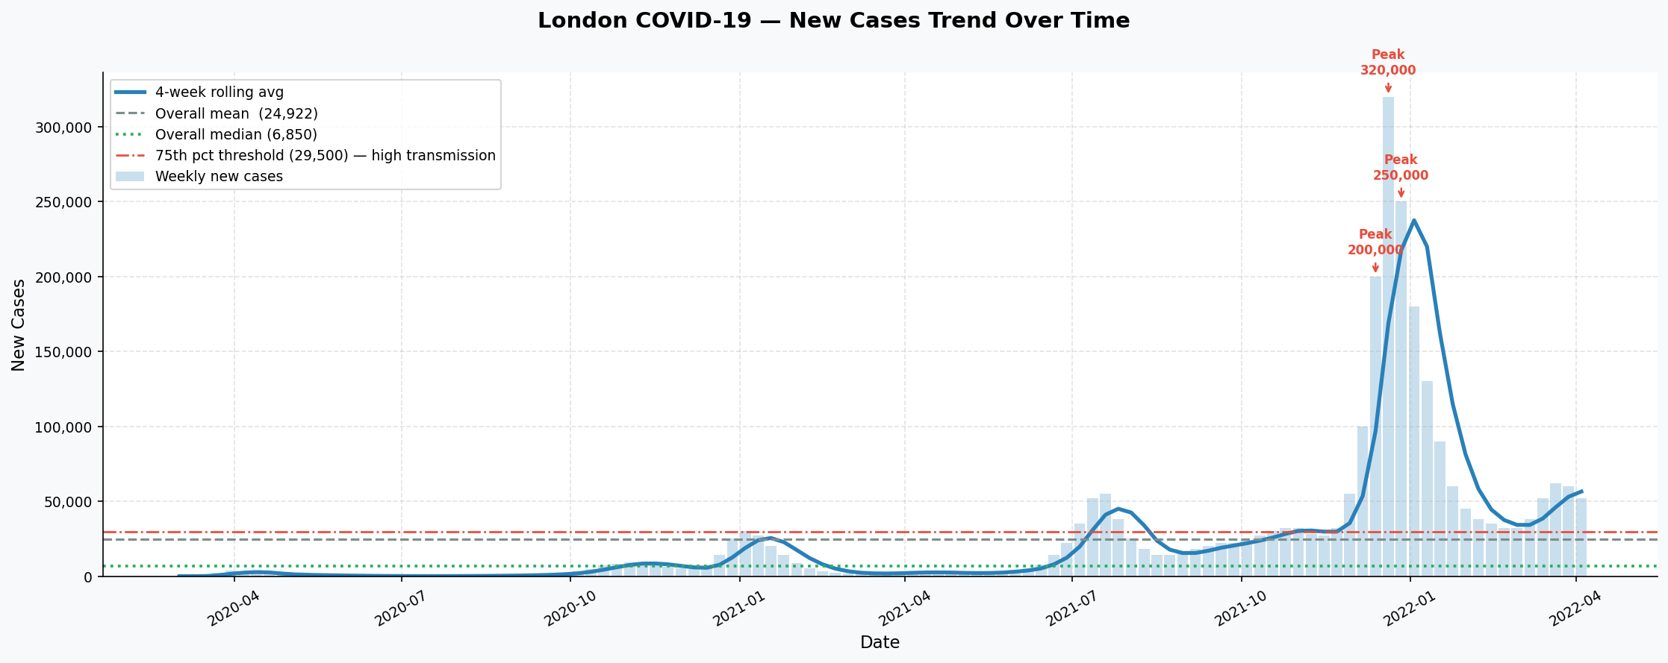
Figure 3: New COVID-19 Cases Over Time with 4-Week Rolling Average, Mean and Median (London)
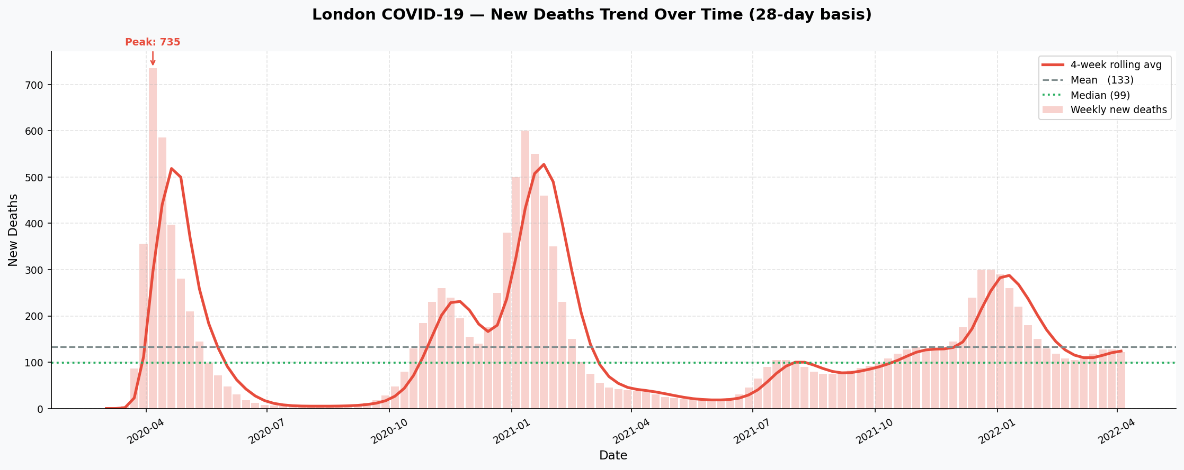
Figure 4: New COVID-19 Deaths (28-day basis) Over Time with 4-Week Rolling Average (London)
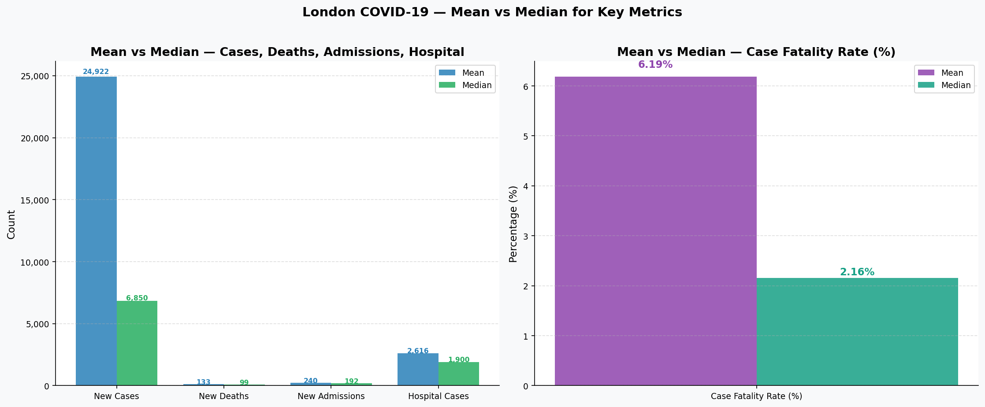
Figure 5: Mean vs Median Comparison for Key COVID-19 Metrics — London, Mar 2020 – Apr 2022
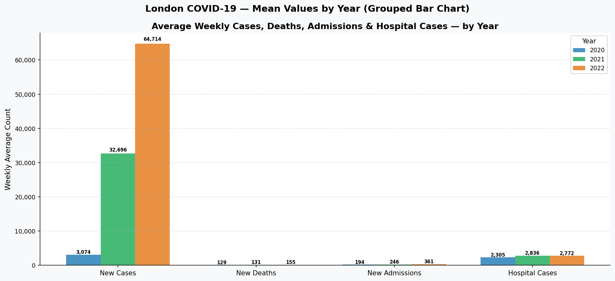
Figure 6: Average Weekly Metrics Grouped by Year (2020, 2021, 2022) — London
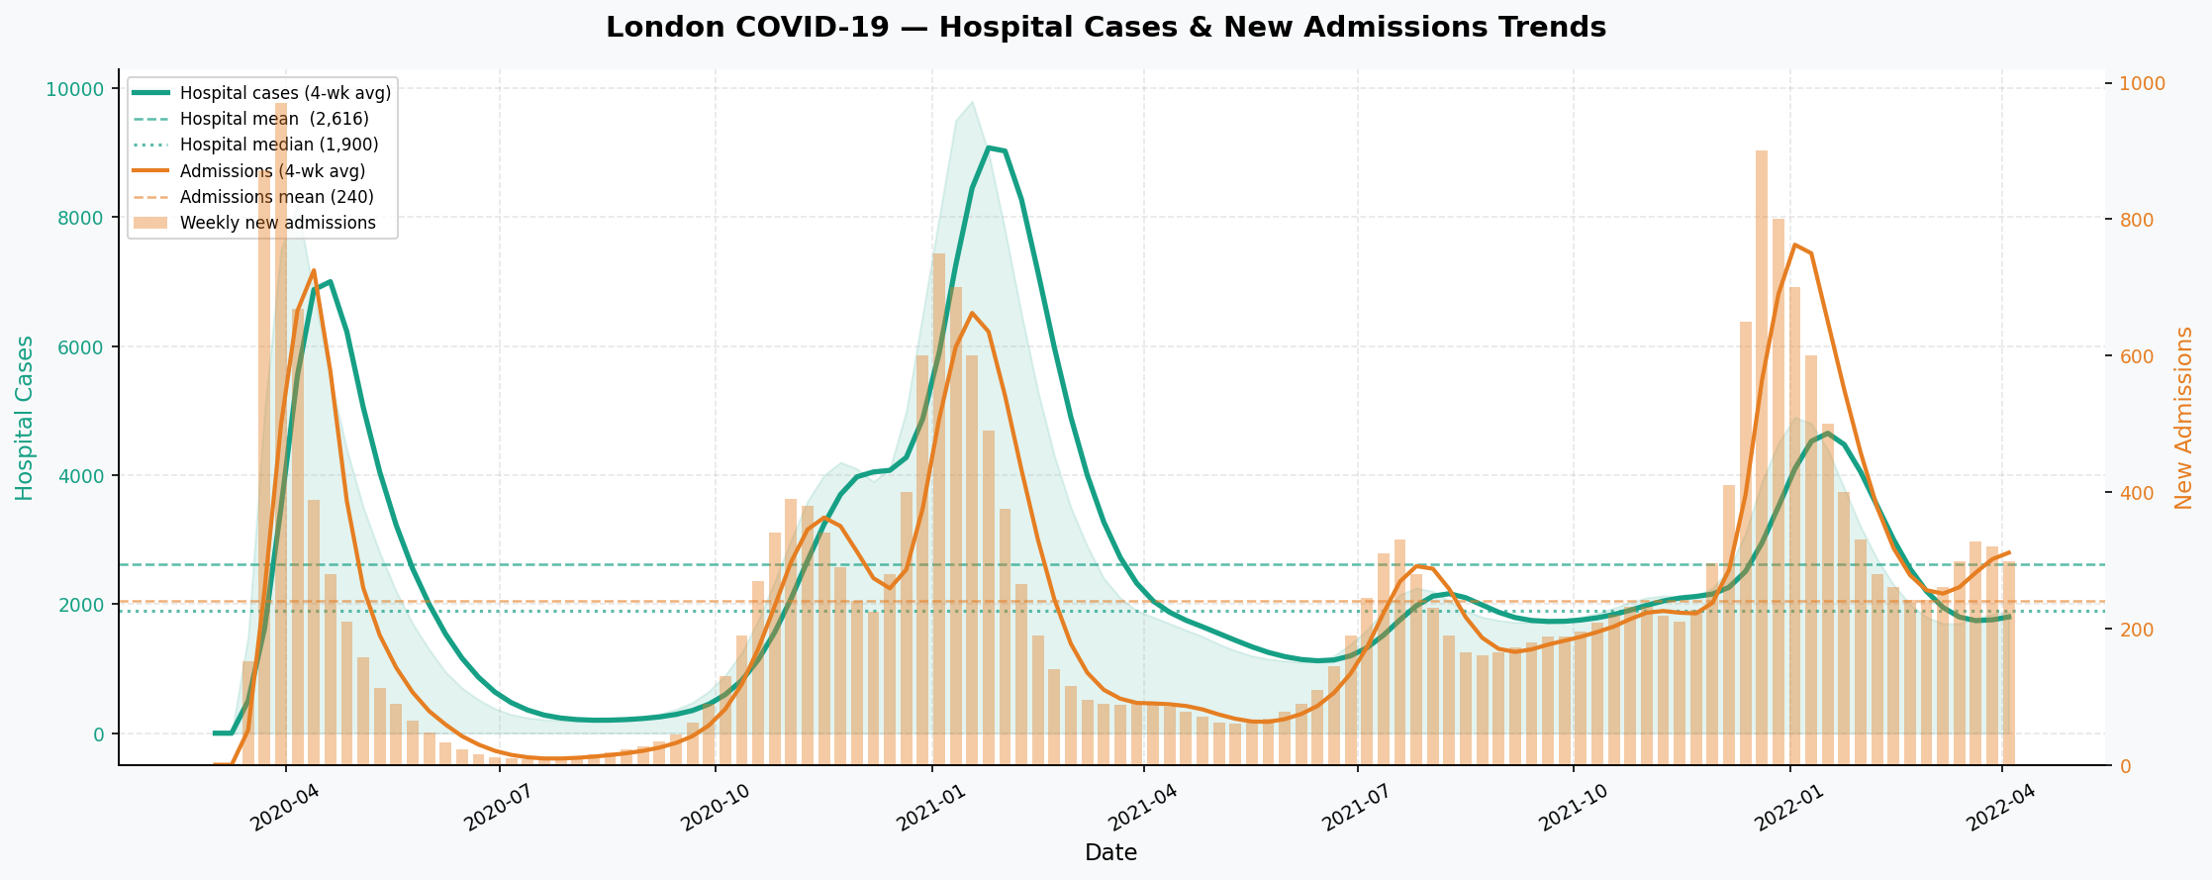
Figure 7: Hospital Cases and New Admissions Trends Over Time — London (Dual-Axis Line Chart)
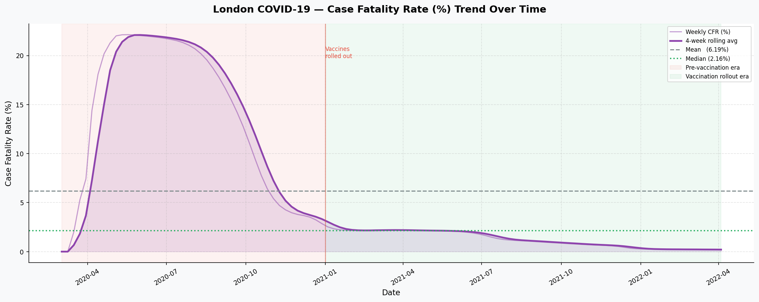
Figure 8: Case Fatality Rate (%) Over Time with Pre- and Post-Vaccination Eras Highlighted — London
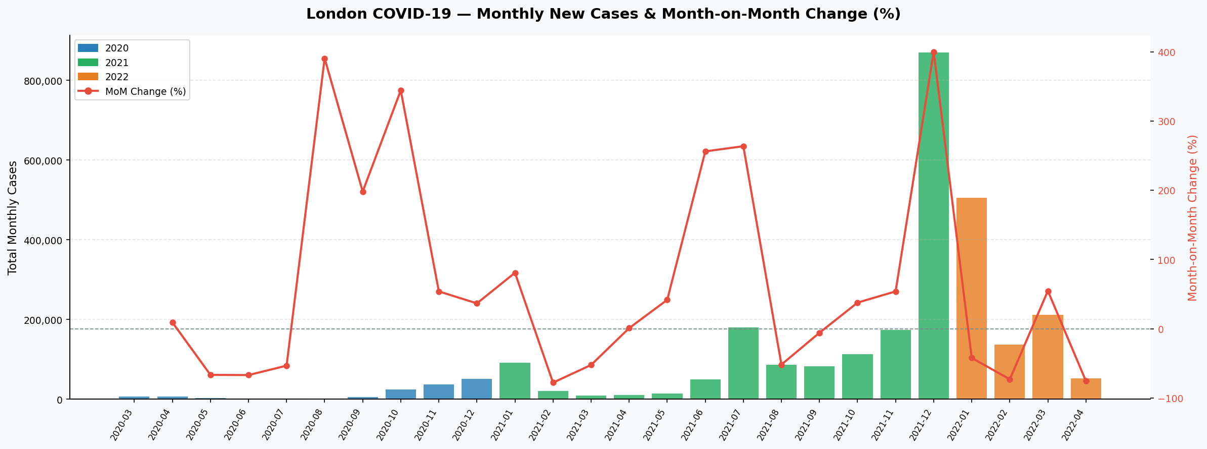
Figure 9: Monthly Total New Cases with Month-on-Month Percentage Change — London
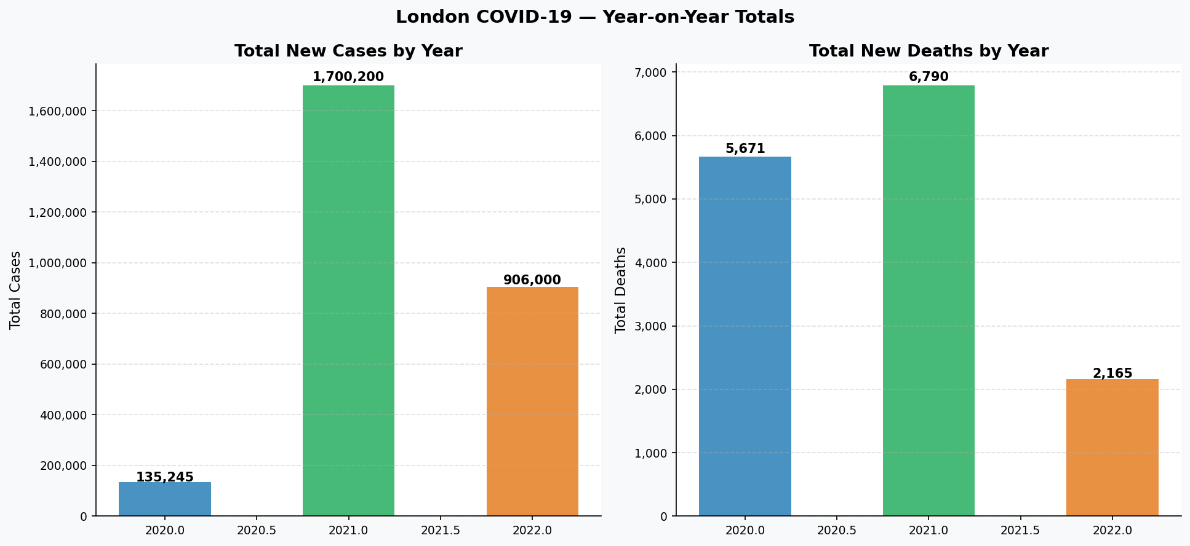
Figure 10: Year-on-Year Total New Cases and Total Deaths — London
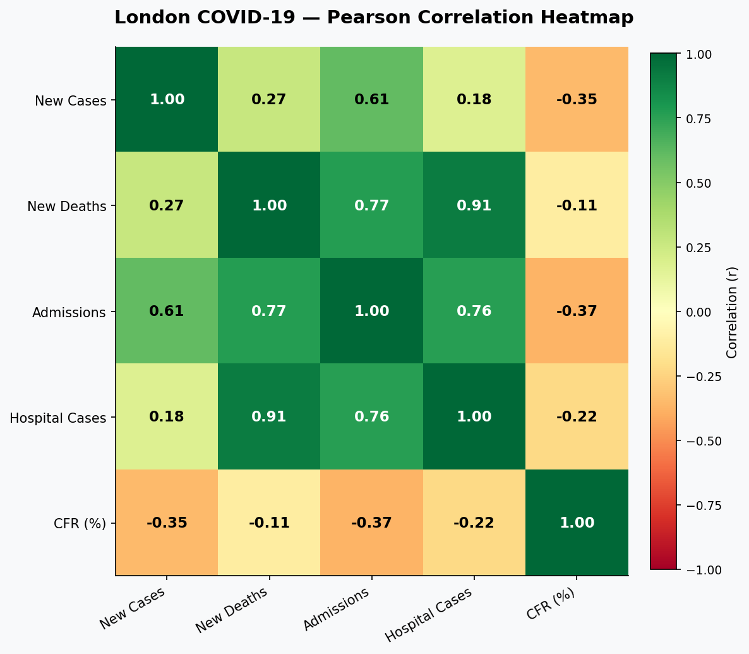
Figure 11: Pearson Correlation Heatmap Across Key COVID-19 Metrics — London
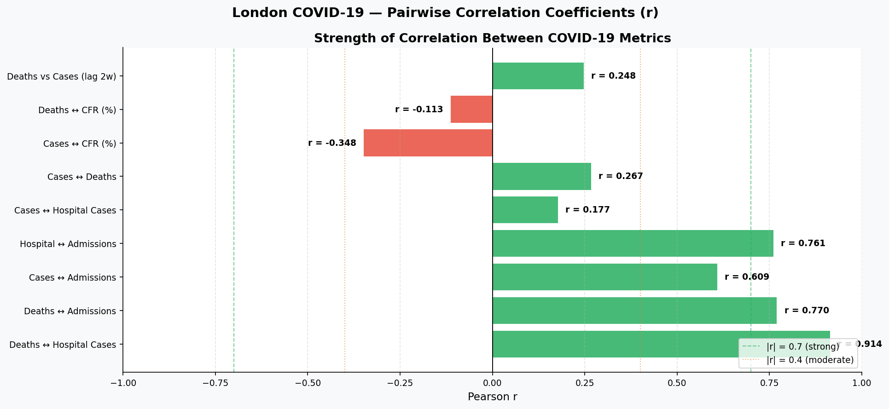
Figure 12: Pairwise Correlation Coefficients (r) Between COVID-19 Metrics — London
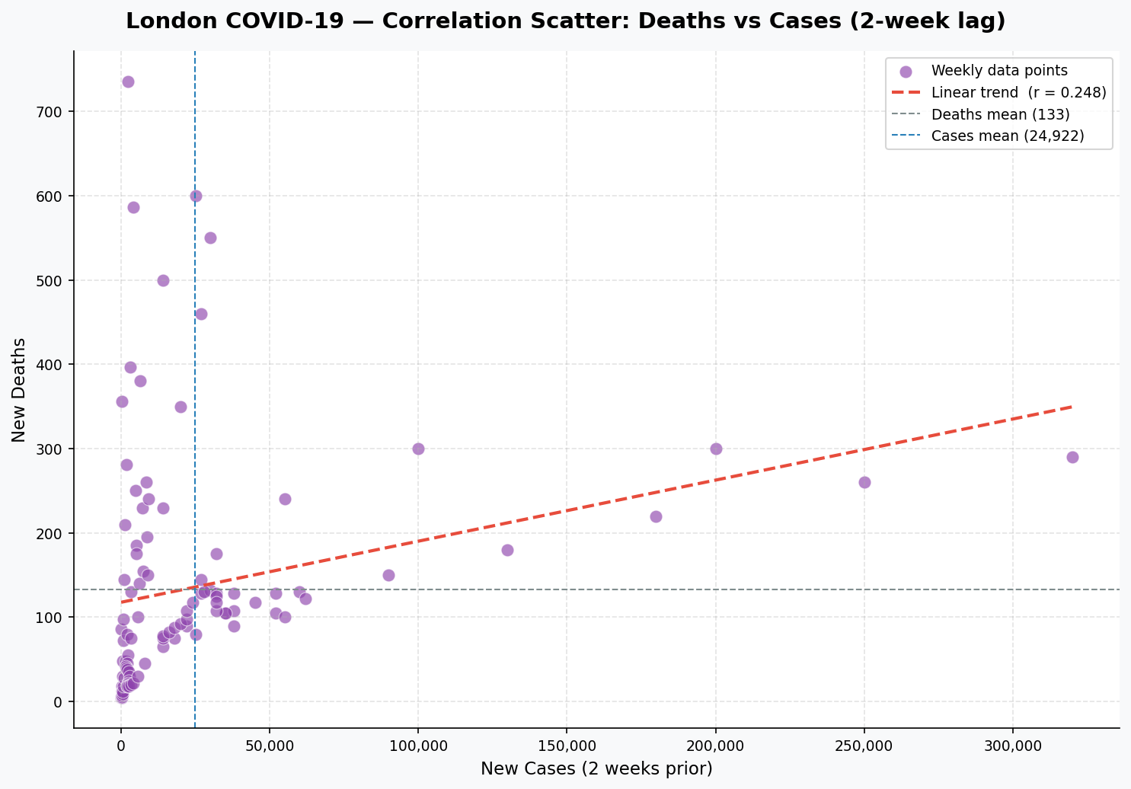
Figure 13: Scatter Plot: New Deaths vs New Cases with 2-Week Lag and Linear Trend Line — London

5.1 Source Code — Visualisations (Unit_5.4_visualisations.py)
# Unit 5.4 - Visualisations: Key Insights from London COVID-19 Analysis
# Source data: Unit_5.3_analysis.py | Clean data: london_covid_clean.csv
# Charts: Bar graphs & Line charts for Mean/Median, Trends, Correlations

import pandas as pd
import numpy as np
import matplotlib
matplotlib.use("Agg")
import matplotlib.pyplot as plt
import matplotlib.ticker as mticker
import matplotlib.patches as mpatches
import os

# ── Shared style ──────────────────────────────────────────────────────────────
plt.rcParams.update({
"font.family" : "DejaVu Sans",
"axes.spines.top" : False,
"axes.spines.right" : False,
"axes.titlesize" : 13,
"axes.titleweight" : "bold",
"axes.labelsize" : 11,
"xtick.labelsize" : 9,
"ytick.labelsize" : 9,
"legend.fontsize" : 9,
"figure.facecolor" : "#f8f9fa",
"axes.facecolor" : "#ffffff",
})

BLUE = "#2980b9"
RED = "#e74c3c"
GREEN = "#27ae60"
PURPLE = "#8e44ad"
ORANGE = "#e67e22"
TEAL = "#16a085"
GREY = "#7f8c8d"
LGREY = "#bdc3c7"

SAVED = []

def fmt_k(x, _):
"""Format axis tick as comma-separated integer."""
return f"{int(x):,}"

def save(fig, filename):
fig.savefig(filename, dpi=150, bbox_inches="tight")
plt.close(fig)
SAVED.append(filename)
print(f" [SAVED] {filename}")

# ── Load & prepare (mirrors Unit_5.3_analysis.py) ────────────────────────────
df = pd.read_csv("london_covid_clean.csv", parse_dates=["date"])
df = df.sort_values("date").reset_index(drop=True)

METRIC_COLS = ["new_cases", "new_deaths", "new_admissions",
"hospital_cases", "case_fatality_rate_pct"]
LABELS = ["New Cases", "New Deaths", "New Admissions",
"Hospital Cases", "Case Fatality\nRate (%)"]
COLOURS = [BLUE, RED, ORANGE, TEAL, PURPLE]

# Rolling averages
df["cases_4wk"] = df["new_cases"].rolling(4, min_periods=1).mean()
df["deaths_4wk"] = df["new_deaths"].rolling(4, min_periods=1).mean()
df["admissions_4wk"] = df["new_admissions"].rolling(4, min_periods=1).mean()
df["hospital_4wk"] = df["hospital_cases"].rolling(4, min_periods=1).mean()
df["cfr_4wk"] = df["case_fatality_rate_pct"].rolling(4, min_periods=1).mean()

# Monthly aggregates
monthly = (df.groupby(["year", "month"])["new_cases"]
.sum().reset_index(name="monthly_cases"))
monthly["label"] = (monthly["year"].astype(str) + "-"
+ monthly["month"].astype(str).str.zfill(2))
monthly["mom_change_pct"] = monthly["monthly_cases"].pct_change().mul(100).round(1)

# Yearly totals
yearly_cases = df.groupby("year")["new_cases"].sum()
yearly_deaths = df.groupby("year")["new_deaths"].sum()

# Correlation matrix & lag
corr_cols = METRIC_COLS
corr_matrix = df[corr_cols].corr().round(3)
df["lag2"] = df["new_cases"].shift(2)
lag_corr = df[["lag2", "new_deaths"]].dropna().corr().iloc[0, 1]

# Wave threshold (75th percentile)
threshold = df["new_cases"].quantile(0.75)

print("Generating charts …\n")

# ═══════════════════════════════════════════════════════════════════════════════
# CHART 1 — Mean vs Median: side-by-side bar chart
# ═══════════════════════════════════════════════════════════════════════════════
fig, axes = plt.subplots(1, 2, figsize=(15, 6))
fig.suptitle("London COVID-19 — Mean vs Median for Key Metrics", fontsize=14,
fontweight="bold", y=1.02)

means = [df[c].mean() for c in METRIC_COLS]
medians = [df[c].median() for c in METRIC_COLS]
x = np.arange(len(METRIC_COLS))
w = 0.38

# Left: cases / deaths / admissions / hospital (large numbers)
ax = axes[0]
b1 = ax.bar(x[:4] - w/2, means[:4], w, label="Mean", color=BLUE, alpha=0.85)
b2 = ax.bar(x[:4] + w/2, medians[:4], w, label="Median", color=GREEN, alpha=0.85)
ax.set_xticks(x[:4])
ax.set_xticklabels(LABELS[:4], fontsize=9)
ax.set_ylabel("Count")
ax.set_title("Mean vs Median — Cases, Deaths, Admissions, Hospital")
ax.yaxis.set_major_formatter(mticker.FuncFormatter(fmt_k))
ax.legend()
ax.grid(axis="y", linestyle="--", alpha=0.4)
for bar in b1:
ax.text(bar.get_x() + bar.get_width()/2, bar.get_height() * 1.01,
f"{bar.get_height():,.0f}", ha="center", fontsize=7.5, color=BLUE, fontweight="bold")
for bar in b2:
ax.text(bar.get_x() + bar.get_width()/2, bar.get_height() * 1.01,
f"{bar.get_height():,.0f}", ha="center", fontsize=7.5, color=GREEN, fontweight="bold")

# Right: CFR % (smaller scale)
ax2 = axes[1]
ax2.bar(0 - w/2, means[4], w, label="Mean", color=PURPLE, alpha=0.85)
ax2.bar(0 + w/2, medians[4], w, label="Median", color=TEAL, alpha=0.85)
ax2.set_xticks([0])
ax2.set_xticklabels(["Case Fatality Rate (%)"])
ax2.set_ylabel("Percentage (%)")
ax2.set_title("Mean vs Median — Case Fatality Rate (%)")
ax2.legend()
ax2.grid(axis="y", linestyle="--", alpha=0.4)
ax2.text(-w/2, means[4] * 1.03, f"{means[4]:.2f}%", ha="center", fontsize=11, color=PURPLE, fontweight="bold")
ax2.text( w/2, medians[4] * 1.03, f"{medians[4]:.2f}%", ha="center", fontsize=11, color=TEAL, fontweight="bold")

plt.tight_layout()
save(fig, "chart_1_mean_vs_median.png")

# ═══════════════════════════════════════════════════════════════════════════════
# CHART 2 — Mean by Year: grouped bar chart
# ═══════════════════════════════════════════════════════════════════════════════
yearly_means = df.groupby("year")[METRIC_COLS[:4]].mean() # exclude CFR (different scale)
years = yearly_means.index.tolist()
n_metrics = 4
n_years = len(years)
x = np.arange(n_metrics)
bar_w = 0.25
year_colours = [BLUE, GREEN, ORANGE]

fig, ax = plt.subplots(figsize=(13, 6))
fig.suptitle("London COVID-19 — Mean Values by Year (Grouped Bar Chart)",
fontsize=14, fontweight="bold")

for i, (year, col) in enumerate(zip(years, year_colours)):
vals = yearly_means.loc[year].values
bars = ax.bar(x + (i - 1) * bar_w, vals, bar_w,
label=str(year), color=col, alpha=0.85)
for bar in bars:
h = bar.get_height()
ax.text(bar.get_x() + bar.get_width()/2, h * 1.01,
f"{h:,.0f}", ha="center", va="bottom", fontsize=7, fontweight="bold")

ax.set_xticks(x)
ax.set_xticklabels(LABELS[:4], fontsize=10)
ax.set_ylabel("Weekly Average Count")
ax.set_title("Average Weekly Cases, Deaths, Admissions & Hospital Cases — by Year")
ax.yaxis.set_major_formatter(mticker.FuncFormatter(fmt_k))
ax.legend(title="Year")
ax.grid(axis="y", linestyle="--", alpha=0.4)
plt.tight_layout()
save(fig, "chart_2_mean_by_year.png")

# ═══════════════════════════════════════════════════════════════════════════════
# CHART 3 — Trend: New Cases line chart + rolling average
# ═══════════════════════════════════════════════════════════════════════════════
fig, ax = plt.subplots(figsize=(15, 6))
fig.suptitle("London COVID-19 — New Cases Trend Over Time", fontsize=14, fontweight="bold")

ax.bar(df["date"], df["new_cases"], width=6, color=BLUE, alpha=0.25, label="Weekly new cases")
ax.plot(df["date"], df["cases_4wk"], color=BLUE, linewidth=2.5, label="4-week rolling avg")
ax.axhline(df["new_cases"].mean(), color=GREY, linestyle="--", linewidth=1.5,
label=f"Overall mean ({df['new_cases'].mean():,.0f})")
ax.axhline(df["new_cases"].median(), color=GREEN, linestyle=":", linewidth=1.8,
label=f"Overall median ({df['new_cases'].median():,.0f})")
ax.axhline(threshold, color=RED, linestyle="-.", linewidth=1.3,
label=f"75th pct threshold ({threshold:,.0f}) — high transmission")

# Annotate wave peaks
for _, row in df.nlargest(3, "new_cases").iterrows():
ax.annotate(f"Peak\n{row['new_cases']:,}",
xy=(row["date"], row["new_cases"]),
xytext=(row["date"], row["new_cases"] + 15000),
ha="center", fontsize=8, color=RED, fontweight="bold",
arrowprops=dict(arrowstyle="->", color=RED, lw=1.2))

ax.set_xlabel("Date")
ax.set_ylabel("New Cases")
ax.yaxis.set_major_formatter(mticker.FuncFormatter(fmt_k))
ax.tick_params(axis="x", rotation=30)
ax.legend(loc="upper left")
ax.grid(linestyle="--", alpha=0.35)
plt.tight_layout()
save(fig, "chart_3_cases_trend.png")

# ═══════════════════════════════════════════════════════════════════════════════
# CHART 4 — Trend: New Deaths line chart + rolling average
# ═══════════════════════════════════════════════════════════════════════════════
fig, ax = plt.subplots(figsize=(15, 6))
fig.suptitle("London COVID-19 — New Deaths Trend Over Time (28-day basis)",
fontsize=14, fontweight="bold")

ax.bar(df["date"], df["new_deaths"], width=6, color=RED, alpha=0.25, label="Weekly new deaths")
ax.plot(df["date"], df["deaths_4wk"], color=RED, linewidth=2.5, label="4-week rolling avg")
ax.axhline(df["new_deaths"].mean(), color=GREY, linestyle="--", linewidth=1.5,
label=f"Mean ({df['new_deaths'].mean():.0f})")
ax.axhline(df["new_deaths"].median(), color=GREEN, linestyle=":", linewidth=1.8,
label=f"Median ({df['new_deaths'].median():.0f})")

# Annotate peak death week
peak_death = df.loc[df["new_deaths"].idxmax()]
ax.annotate(f"Peak: {peak_death['new_deaths']:,}",
xy=(peak_death["date"], peak_death["new_deaths"]),
xytext=(peak_death["date"], peak_death["new_deaths"] + 50),
ha="center", fontsize=9, color=RED, fontweight="bold",
arrowprops=dict(arrowstyle="->", color=RED, lw=1.2))

ax.set_xlabel("Date")
ax.set_ylabel("New Deaths")
ax.tick_params(axis="x", rotation=30)
ax.legend(loc="upper right")
ax.grid(linestyle="--", alpha=0.35)
plt.tight_layout()
save(fig, "chart_4_deaths_trend.png")

# ═══════════════════════════════════════════════════════════════════════════════
# CHART 5 — Trend: Hospital Cases + Admissions (dual-line chart)
# ═══════════════════════════════════════════════════════════════════════════════
fig, ax1 = plt.subplots(figsize=(15, 6))
fig.suptitle("London COVID-19 — Hospital Cases & New Admissions Trends",
fontsize=14, fontweight="bold")

ax1.plot(df["date"], df["hospital_4wk"], color=TEAL, linewidth=2.5,
label="Hospital cases (4-wk avg)")
ax1.fill_between(df["date"], df["hospital_cases"], alpha=0.12, color=TEAL)
ax1.set_xlabel("Date")
ax1.set_ylabel("Hospital Cases", color=TEAL)
ax1.tick_params(axis="y", labelcolor=TEAL)
ax1.tick_params(axis="x", rotation=30)
ax1.axhline(df["hospital_cases"].mean(), color=TEAL, linestyle="--", linewidth=1.2, alpha=0.7,
label=f"Hospital mean ({df['hospital_cases'].mean():,.0f})")
ax1.axhline(df["hospital_cases"].median(), color=TEAL, linestyle=":", linewidth=1.5, alpha=0.7,
label=f"Hospital median ({df['hospital_cases'].median():,.0f})")

ax2 = ax1.twinx()
ax2.bar(df["date"], df["new_admissions"], width=5, color=ORANGE, alpha=0.4,
label="Weekly new admissions")
ax2.plot(df["date"], df["admissions_4wk"], color=ORANGE, linewidth=2,
label="Admissions (4-wk avg)")
ax2.set_ylabel("New Admissions", color=ORANGE)
ax2.tick_params(axis="y", labelcolor=ORANGE)
ax2.axhline(df["new_admissions"].mean(), color=ORANGE, linestyle="--", linewidth=1.2, alpha=0.6,
label=f"Admissions mean ({df['new_admissions'].mean():.0f})")

lines1, labels1 = ax1.get_legend_handles_labels()
lines2, labels2 = ax2.get_legend_handles_labels()
ax1.legend(lines1 + lines2, labels1 + labels2, loc="upper left", fontsize=8)
ax1.grid(linestyle="--", alpha=0.3)
plt.tight_layout()
save(fig, "chart_5_hospital_admissions_trend.png")

# ═══════════════════════════════════════════════════════════════════════════════
# CHART 6 — Trend: Case Fatality Rate over time
# ═══════════════════════════════════════════════════════════════════════════════
fig, ax = plt.subplots(figsize=(15, 6))
fig.suptitle("London COVID-19 — Case Fatality Rate (%) Trend Over Time",
fontsize=14, fontweight="bold")

ax.plot(df["date"], df["case_fatality_rate_pct"], color=PURPLE, linewidth=1.5,
alpha=0.5, label="Weekly CFR (%)")
ax.plot(df["date"], df["cfr_4wk"], color=PURPLE, linewidth=2.5,
label="4-week rolling avg")
ax.fill_between(df["date"], df["cfr_4wk"], alpha=0.15, color=PURPLE)
ax.axhline(df["case_fatality_rate_pct"].mean(), color=GREY, linestyle="--", linewidth=1.5,
label=f"Mean ({df['case_fatality_rate_pct'].mean():.2f}%)")
ax.axhline(df["case_fatality_rate_pct"].median(), color=GREEN, linestyle=":", linewidth=1.8,
label=f"Median ({df['case_fatality_rate_pct'].median():.2f}%)")

# Shade pre- vs post-vaccination
vax_date = pd.Timestamp("2021-01-01")
ax.axvspan(df["date"].min(), vax_date, alpha=0.07, color=RED, label="Pre-vaccination era")
ax.axvspan(vax_date, df["date"].max(), alpha=0.07, color=GREEN, label="Vaccination rollout era")
ax.axvline(vax_date, color=RED, linestyle="-", linewidth=1.2, alpha=0.5)
ax.text(vax_date, ax.get_ylim()[1] * 0.85 if ax.get_ylim()[1] > 0 else 18,
"Vaccines\nrolled out", fontsize=8, color=RED, ha="left")

ax.set_xlabel("Date")
ax.set_ylabel("Case Fatality Rate (%)")
ax.tick_params(axis="x", rotation=30)
ax.legend(loc="upper right", fontsize=8)
ax.grid(linestyle="--", alpha=0.35)
plt.tight_layout()
save(fig, "chart_6_cfr_trend.png")

# ═══════════════════════════════════════════════════════════════════════════════
# CHART 7 — Monthly Cases: bar chart with MoM % change line overlay
# ═══════════════════════════════════════════════════════════════════════════════
fig, ax1 = plt.subplots(figsize=(16, 6))
fig.suptitle("London COVID-19 — Monthly New Cases & Month-on-Month Change (%)",
fontsize=14, fontweight="bold")

yr_cols = {2020: BLUE, 2021: GREEN, 2022: ORANGE}
bar_colours = [yr_cols[y] for y in monthly["year"]]
xpos = range(len(monthly))

ax1.bar(xpos, monthly["monthly_cases"], color=bar_colours, alpha=0.82)
ax1.set_xticks(list(xpos))
ax1.set_xticklabels(monthly["label"], rotation=60, ha="right", fontsize=8)
ax1.set_ylabel("Total Monthly Cases")
ax1.yaxis.set_major_formatter(mticker.FuncFormatter(fmt_k))
ax1.grid(axis="y", linestyle="--", alpha=0.35)

# MoM % change overlay on secondary axis
ax2 = ax1.twinx()
ax2.plot(list(xpos), monthly["mom_change_pct"], color=RED, linewidth=2,
marker="o", markersize=5, label="MoM change (%)", zorder=5)
ax2.axhline(0, color=GREY, linestyle="--", linewidth=0.9)
ax2.set_ylabel("Month-on-Month Change (%)", color=RED)
ax2.tick_params(axis="y", labelcolor=RED)

# Legend patches
patches = [mpatches.Patch(color=BLUE, label="2020"),
mpatches.Patch(color=GREEN, label="2021"),
mpatches.Patch(color=ORANGE, label="2022"),
plt.Line2D([0], [0], color=RED, linewidth=2, marker="o", label="MoM Change (%)")]
ax1.legend(handles=patches, loc="upper left", fontsize=9)
plt.tight_layout()
save(fig, "chart_7_monthly_cases_bar.png")

# ═══════════════════════════════════════════════════════════════════════════════
# CHART 8 — Yearly totals: side-by-side bar chart (cases vs deaths)
# ═══════════════════════════════════════════════════════════════════════════════
fig, axes = plt.subplots(1, 2, figsize=(13, 6))
fig.suptitle("London COVID-19 — Year-on-Year Totals", fontsize=14, fontweight="bold")

years = yearly_cases.index.tolist()
yc_vals = yearly_cases.values
yd_vals = yearly_deaths.values
yc_cols = [BLUE, GREEN, ORANGE]

ax = axes[0]
bars = ax.bar(years, yc_vals, color=yc_cols, alpha=0.85, width=0.5)
ax.set_title("Total New Cases by Year")
ax.set_ylabel("Total Cases")
ax.yaxis.set_major_formatter(mticker.FuncFormatter(fmt_k))
ax.grid(axis="y", linestyle="--", alpha=0.4)
for bar, val in zip(bars, yc_vals):
ax.text(bar.get_x() + bar.get_width()/2, bar.get_height() * 1.01,
f"{val:,}", ha="center", fontsize=10, fontweight="bold")

ax = axes[1]
bars = ax.bar(years, yd_vals, color=yc_cols, alpha=0.85, width=0.5)
ax.set_title("Total New Deaths by Year")
ax.set_ylabel("Total Deaths")
ax.yaxis.set_major_formatter(mticker.FuncFormatter(fmt_k))
ax.grid(axis="y", linestyle="--", alpha=0.4)
for bar, val in zip(bars, yd_vals):
ax.text(bar.get_x() + bar.get_width()/2, bar.get_height() * 1.01,
f"{val:,}", ha="center", fontsize=10, fontweight="bold")

plt.tight_layout()
save(fig, "chart_8_yearly_totals.png")

# ═══════════════════════════════════════════════════════════════════════════════
# CHART 9 — Correlation heatmap (standalone)
# ═══════════════════════════════════════════════════════════════════════════════
short = ["New Cases", "New Deaths", "Admissions", "Hospital Cases", "CFR (%)"]

fig, ax = plt.subplots(figsize=(8, 7))
fig.suptitle("London COVID-19 — Pearson Correlation Heatmap",
fontsize=14, fontweight="bold")

im = ax.imshow(corr_matrix.values, cmap="RdYlGn", vmin=-1, vmax=1, aspect="auto")
ax.set_xticks(range(5)); ax.set_yticks(range(5))
ax.set_xticklabels(short, rotation=30, ha="right", fontsize=10)
ax.set_yticklabels(short, fontsize=10)
cbar = plt.colorbar(im, ax=ax, fraction=0.046, pad=0.04)
cbar.set_label("Correlation (r)", fontsize=10)

for i in range(5):
for j in range(5):
val = corr_matrix.values[i, j]
txt_col = "white" if abs(val) > 0.65 else "black"
ax.text(j, i, f"{val:.2f}", ha="center", va="center",
fontsize=11, fontweight="bold", color=txt_col)

plt.tight_layout()
save(fig, "chart_9_correlation_heatmap.png")

# ═══════════════════════════════════════════════════════════════════════════════
# CHART 10 — Correlation bar chart (r values for each pair)
# ═══════════════════════════════════════════════════════════════════════════════
pairs = [
("Deaths ↔ Hospital Cases", corr_matrix.loc["new_deaths", "hospital_cases"]),
("Deaths ↔ Admissions", corr_matrix.loc["new_deaths", "new_admissions"]),
("Cases ↔ Admissions", corr_matrix.loc["new_cases", "new_admissions"]),
("Hospital ↔ Admissions", corr_matrix.loc["hospital_cases", "new_admissions"]),
("Cases ↔ Hospital Cases", corr_matrix.loc["new_cases", "hospital_cases"]),
("Cases ↔ Deaths", corr_matrix.loc["new_cases", "new_deaths"]),
("Cases ↔ CFR (%)", corr_matrix.loc["new_cases", "case_fatality_rate_pct"]),
("Deaths ↔ CFR (%)", corr_matrix.loc["new_deaths", "case_fatality_rate_pct"]),
("Deaths vs Cases (lag 2w)", lag_corr),
]
pair_labels = [p[0] for p in pairs]
pair_vals = [p[1] for p in pairs]
bar_cols = [GREEN if v >= 0 else RED for v in pair_vals]

fig, ax = plt.subplots(figsize=(13, 6))
fig.suptitle("London COVID-19 — Pairwise Correlation Coefficients (r)",
fontsize=14, fontweight="bold")

bars = ax.barh(pair_labels, pair_vals, color=bar_cols, alpha=0.85)
ax.axvline(0, color="black", linewidth=0.9)
ax.axvline( 0.7, color=GREEN, linestyle="--", linewidth=1, alpha=0.6, label="|r| = 0.7 (strong)")
ax.axvline(-0.7, color=GREEN, linestyle="--", linewidth=1, alpha=0.6)
ax.axvline( 0.4, color=ORANGE, linestyle=":", linewidth=1, alpha=0.6, label="|r| = 0.4 (moderate)")
ax.axvline(-0.4, color=ORANGE, linestyle=":", linewidth=1, alpha=0.6)
ax.set_xlabel("Pearson r")
ax.set_title("Strength of Correlation Between COVID-19 Metrics")
ax.set_xlim(-1, 1)
ax.grid(axis="x", linestyle="--", alpha=0.35)
ax.legend(loc="lower right")
for bar, val in zip(bars, pair_vals):
xpos = val + 0.02 if val >= 0 else val - 0.02
ha = "left" if val >= 0 else "right"
ax.text(xpos, bar.get_y() + bar.get_height()/2,
f"r = {val:.3f}", va="center", ha=ha, fontsize=9, fontweight="bold")

plt.tight_layout()
save(fig, "chart_10_correlation_bars.png")

# ═══════════════════════════════════════════════════════════════════════════════
# CHART 11 — Scatter: Cases vs Deaths (2-week lag) with trend line
# ═══════════════════════════════════════════════════════════════════════════════
valid = df[["lag2", "new_deaths"]].dropna()
z = np.polyfit(valid["lag2"], valid["new_deaths"], 1)
p_fit = np.poly1d(z)
x_ln = np.linspace(valid["lag2"].min(), valid["lag2"].max(), 300)

fig, ax = plt.subplots(figsize=(10, 7))
fig.suptitle("London COVID-19 — Correlation Scatter: Deaths vs Cases (2-week lag)",
fontsize=14, fontweight="bold")

sc = ax.scatter(valid["lag2"], valid["new_deaths"],
alpha=0.65, color=PURPLE, edgecolors="white", linewidths=0.5, s=65,
label="Weekly data points")
ax.plot(x_ln, p_fit(x_ln), color=RED, linewidth=2, linestyle="--",
label=f"Linear trend (r = {lag_corr:.3f})")
ax.axhline(df["new_deaths"].mean(), color=GREY, linestyle="--", linewidth=1,
label=f"Deaths mean ({df['new_deaths'].mean():.0f})")
ax.axvline(df["new_cases"].mean(), color=BLUE, linestyle="--", linewidth=1,
label=f"Cases mean ({df['new_cases'].mean():,.0f})")

ax.set_xlabel("New Cases (2 weeks prior)")
ax.set_ylabel("New Deaths")
ax.xaxis.set_major_formatter(mticker.FuncFormatter(fmt_k))
ax.legend()
ax.grid(linestyle="--", alpha=0.35)
plt.tight_layout()
save(fig, "chart_11_scatter_lag_correlation.png")

# ─────────────────────────────────────────────────────────────────────────────
print(f"\nAll {len(SAVED)} charts saved:")
for s in SAVED:
print(f" → {os.path.abspath(s)}")

6. Critical Reflection
This analysis successfully demonstrated an end-to-end data science pipeline — from acquisition through cleaning, statistical analysis, and visualisation — applied to a real-world public health dataset. The use of Pandas enabled efficient tabular operations, while Matplotlib produced clear, publication-quality charts (McKinney, 2010; Hunter, 2007). Rolling averages and correlation matrices effectively surfaced meaningful epidemiological patterns, including the three transmission waves and the progressive decoupling of case counts from mortality following vaccination.
Nevertheless, several limitations merit acknowledgement. The dataset represents weekly aggregates at the regional level, which obscures borough-level heterogeneity within London — a city of considerable socioeconomic and demographic diversity. Imputing early missing values with zero, while contextually reasonable, introduces a minor distortion in cumulative statistics for the earliest weeks. Furthermore, the Pearson correlation assumes linearity, which may not fully capture the complex, non-linear dynamics of pandemic transmission (Haas et al., 2021).
Future analyses should incorporate demographic stratification, borough-level granularity, and vaccination uptake rates to improve explanatory power. Machine learning models, such as ARIMA or LSTM networks, could be applied to generate short-term case forecasts, extending the utility of this dataset beyond descriptive analysis (Twohig et al., 2022). Despite these limitations, the findings provide a robust, data-driven overview of London's COVID-19 trajectory and the measurable impact of public health interventions.

7. References
Haas, E.J., Angulo, F.J., McLaughlin, J.M., Anis, E., Singer, S.R., Khan, F., Brooks, N., Smaja, M., Mircus, G., Pan, K., Southern, J., Swerdlow, D.L., Jodar, L., Levy, Y. and Alroy-Preis, S. (2021) 'Impact and effectiveness of mRNA BNT162b2 vaccine against SARS-CoV-2 infections and COVID-19 cases, hospitalisations, and deaths following a nationwide vaccination campaign in Israel', The Lancet, 397(10287), pp. 1819–1829. Available at: https://doi.org/10.1016/S0140-6736(21)00947-8 (Accessed: 28 February 2026).
Hunter, J.D. (2007) 'Matplotlib: A 2D graphics environment', Computing in Science and Engineering, 9(3), pp. 90–95. Available at: https://doi.org/10.1109/MCSE.2007.55 (Accessed: 28 February 2026).
McKinney, W. (2010) 'Data structures for statistical computing in Python', Proceedings of the 9th Python in Science Conference, pp. 56–61. Available at: https://doi.org/10.25080/Majora-92bf1922-00a (Accessed: 28 February 2026).
Sadalage, P.J. and Fowler, M. (2012) NoSQL Distilled: A Brief Guide to the Emerging World of Polyglot Persistence. Boston: Addison-Wesley.
Stonebraker, M. (2010) 'SQL databases v. NoSQL databases', Communications of the ACM, 53(4), pp. 10–11. Available at: https://doi.org/10.1145/1721654.1721659 (Accessed: 28 February 2026).
Twohig, K.A., Nyberg, T., Zaidi, A., Thelwall, S., Sinnathamby, M.A., Aliabadi, S., Seaman, S.R., Harris, R.J., Hope, R., Lopez-Bernal, J., Charlett, A., De Angelis, D., Presanis, A.M. and Dabrera, G. (2022) 'Hospital admission and emergency care attendance risk for SARS-CoV-2 delta (B.1.617.2) compared with alpha (B.1.1.7) variants of concern: a cohort study', The Lancet Infectious Diseases, 22(1), pp. 35–42. Available at: https://doi.org/10.1016/S1473-3099(21)00475-8 (Accessed: 28 February 2026).
UK Health Security Agency (2022) Coronavirus (COVID-19) in the UK Dashboard. Available at: https://coronavirus.data.gov.uk (Accessed: 28 February 2026).
Wickham, H. (2014) 'Tidy data', Journal of Statistical Software, 59(10), pp. 1–23. Available at: https://doi.org/10.18637/jss.v059.i10 (Accessed: 28 February 2026).

